S U R V E Y I N G

Lecture Notes

Draft

Introduction

Surveying (Land Surveying in the US) is the art of making measurements of relative positions of natural and man-made features on the Earth’s surface, and the presentation of this information graphically, or numerically.
Definition of Surveying

In many languages there are no real distinctions between the words Surveying and Geodesy. However in English the two terms show a distinction between two somewhat different, but closely linked sciences. In contrary to the definition of Surveying, Geodesy can be defined as the discipline that deals with the measurement and representation of the Earth, including its shape and gravity field. Geodesy studies these properties in a three-dimensional time-varying space. According to Krakiwsky and Vanicek (1986) Surveying can be defined as the practice of positioning, while Geodesy is necessary for the theoretical foundation of Surveying.

One could also say that Geodesy focuses on the Earth and neglects any man-made features on it (e.g. buildings, public utilities, dams, etc.), while surveying use the results of Geodesy for positioning and mapping these features.

Surveying is an ancient profession. The first surveying works date back to the antiquity. Euclid (300 BC) founded the theoretical background of surveying by the development of geometry. Eratosthenes discovered the spherical Earth by experiencing that a column in Alexandria had a shadow exactly at the same time when the shadow disappeared in a well in Syene at noontime. These experiences lead him to the idea that the Earth is not planar, but spherical instead. He managed to compute the size of the Earth, which was found to be 39.790 stadia (approx. 6.255 km). This result is quite remarkable, since currently the radius of the Earth is 6.378 km.

Basic Principles of Surveying
Surveying is the profession of measuring the positions of various features. In order to represent these positions, one needs a kind of coordinate system. The working area of Surveying is the three-dimensional world (sometimes the time, as the fourth dimension is also used to define the time varying position of a moving point). However due to technical and physical reasons the relative positioning in Surveying is usually done in two distinct coordinate systems. The horizontal coordinate system represents the lateral positions of the features, while the vertical coordinate system represents the elevation of the points above a certain reference surface (for example the Mean Sea Level – MSL).
The coordinate system

Axises of the horizontal coordinate system (a coordinate system in a horizontal plane) in Surveying is usually oriented to the North and the East. Thus the coordinates are referred as Northing and Easting. Northing is the shortest horizontal distance between the Easting axis of the coordinate system and the observed point, while Easting is the shortest horizontal distance between the Northing axis and the point.

The vertical coordinate system is a one-dimensional coordinate system. The elevation of a point is defined as the distance between the point and a reference surface, which is usually the Mean Sea Level.

It is trivial that these coordinate systems are only virtual coordinate systems. They are not visible on the working area of a surveyor. However a two-dimensional orthogonal coordinate system can be restored anytime, when the coordinates of two points are known in this coordinate system. These points are known as control points (or benchmarks). A control point is a point that is marked on the field and its coordinates have already been defined in the coordinate system. Control points are used as reference points for the surveying activities, and relative positions are measured referring to these control points.

Control points

It must be noted, that these definitions are rather simplified, more details on the definition of coordinate systems will be given later.

What is the principle of relative positioning, and how can the position of any point be computed in the coordinate system? If one assumes that the horizontal coordinates of point P should be computed, then two unknowns must be determined: the Easting and the Northing coordinates of point P. In order to do this, one needs a minimum of two observations as well.
Principle of relative positioning
We either measure
- two distances from two control points (for which the coordinates are known);
- one distance from a control point, and an angle referring to a baseline determined by two control points;
- two angles referring to a baseline determined by two control points.

The classification of surveying
The activities of surveying can be classified using various aspects. According to the space involved, surveying can be classified into:
Plane surveying; and
Geodetic surveying.

Plane surveying deals with relatively small areas. When the size of the working area is comparably small to the radius of the Earth, then the two radii drawn to point A and point B are parallel. Thus the curvature of the Earth can be neglected (planar approximation). In this case the plotted distances are the horizontal projection of the measured slope distances (Fig. 1-1.).

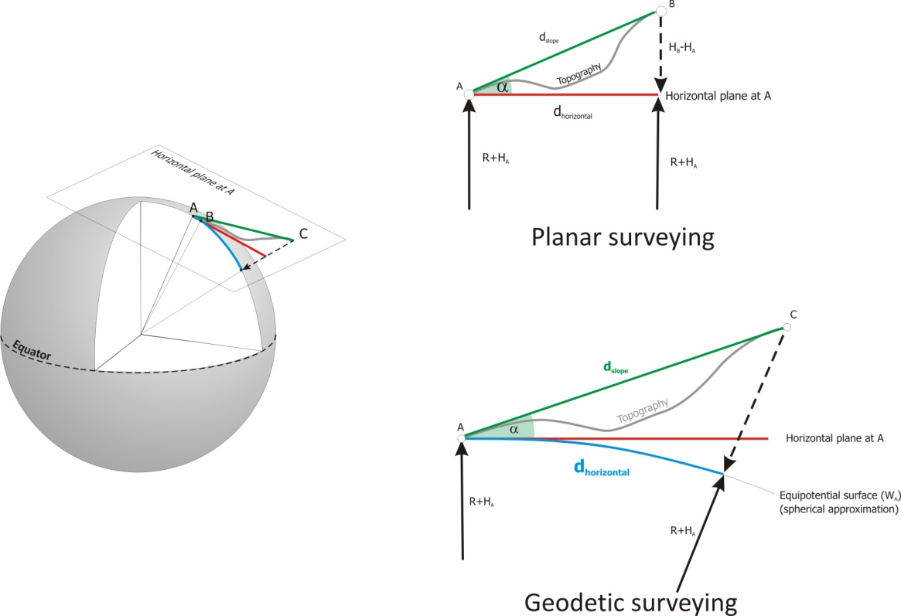

Figure 1.1 Geodetic and planar surveying

Geodetic surveying deals with large areas. In this case the radii drawn to A and C are not parallel due to the Earth’s curvature. Thus the surface of the Earth can not supposed to be flat. In this case the shape of the Earth is usually supposed to be spherical or ellipsoidal. Geodetic surveying is mostly used for:
- establishing control networks over a larger area;
- determining the shape of the Earth; and
- determining the gravity field of the Earth.

Geodetic Control Networks
For the definition of the Geodetic Coordinate System, a minimum of two control points are necessary. In order to enable the surveying and construction work over a large area a bunch of control points are determined on a national – and sometimes on an international – level. These control points form a Geodetic Control Network. Geodetic control networks have two important characteristics:
Hierarchy: Geodetic Control Networks are developed on a hierarchical basis. The first order network is the sparsest network. For example the average distance between the first order horizontal geodetic control points is 30 kilometers in Hungary. In the second step the first order network is densified, and the second order network is created (average distance of 15 km). For the computation of the second order geodetic control network the coordinates of the first order network are used as fixed reference coordinates. After the development of the second order control network, the third order network is created by densifying the second order network (average distance of 7 km). The fourth order network is developed from the third order network.
The hierarchical development of the control networks help to limit the effect of the propagation of observation error. Since the coordinates of the control points are kept fixed in a higher order network during the establishment of the networks with a lower order, an upper bound for the propagation of observation errors is introduced.
Separation: Usually the horizontal and vertical control networks are separated. The reason for this is the different measurement procedures of horizontal and vertical coordinate determination.
Horizontal control points are usually established on hill tops due to the large distance and intervisibility requirements between the points. Vertical control points must be established on buildings and structures with an appropriate funding to avoid the displacement of the control points. Since it is very unlikely that founded buildings can be found on hill tops in every 30 kilometres, therefore the control networks are usually separated.

Branches of Surveying

Topographic Surveying
The topographic surveying is focusing on the production of medium and small-scale maps (1:10000 – 1:200000). These maps represent the topography, waterways, roads, railways. Smaller local features, which are necessary for orientation and transportation, or even military purposes (churches, bridges, etc.) are represented by symbols.

Photogrammetry
The position of points can also been determined by taking a photo of the unknown points and some reference control points. Usually special professional cameras are used for this purpose. Photogrammetry can be classified into two types:
Aerial photogrammetry: Photos are taken from airplanes. The main purpose of this activity is the mapping of large areas.
Close range photogrammetry: Photos are taken from simple tripods. For example the scaffolding of buildings can be documented with this approach for renovation purposes.
The major difference between photogrammetry and photography is the fact that the processed images created by photogrammetry are suitable for measuring accurate positions from the images directly.

Cadastral Surveying
The aim of cadastral surveying is the mapping of and recording the boundaries and ownership of land and property, and the boundaries of different land usages.

Engineering Surveying
Engineering Surveying embraces all the surveying works required before, during and after any engineering (construction) work, such as:
Producing plans (large scale) or numeric data for engineering projects: The basis of the construction planning is the actual state of the construction site. Therefore the topography, the roads, utility manholes, pipes, electric wires, etc. in the site and in the neighbouring plots must be surveyed.
Determining areas and volumes: the computation of the quantity of the earthwork is necessary in the planning phase of the construction for the pricing. During the construction phase the billing of subcontractors can be checked by continuously measuring the volume of the earthwork.
Providing permanent control points for other surveying tasks: Engineering Surveying Control Networks are somewhat different from the geodetic control networks used in land surveying. Usually the accuracy requirements are higher, and sometimes the coordinate systems are also different.
Setting out engineering constructions: In order to be able to construct an object, first the shape of the foundation must be marked on the field. During the construction the marking of positions of pillars, walls, different parts of the structure must be done, too.
Supervising the correctness of construction: Measuring the position of the built structural parts, and judging the quality of the construction works (verticality and roughness of walls, deformation of bridges under test loads, position and verticality of pillars, etc.);
Recording the final as-built position of construction: After the construction, the as-built position of the structures must be recorded. In many cases the structures, or some rights linked to the structures (e.g. rights to the maintenance of pipes) must be recorded in the land registry.

Methods of height determination

In this section various methods of the determination of vertical coordinates are discussed. But before discussing the methods, some general questions should be clarified:

Question 1: What does the elevation of a point mean?
Question 2: What does it mean, when point B has a higher elevation than point A?

In the first sense the elevation of a point is the distance between the point and the Mean Sea Level (MSL). This definition seems to be simple, but how to define and measure the distance between a point and the mean sea level over the continents? Shall we measure the distance along a straight line, or along a curve? On the other hand, how shall we define the mean sea level beneath the continents? To find the answers to these questions one should also take into account the application of elevation data. Why do we need elevation at all? In the engineering practice elevation data is directly linked to the potential energy of the point. When a point has a higher elevation than another, it must mean in the engineering practice that water flows from the first point to the latter. So the answers for the first two questions are:

Answer 1: The elevation of a point must represent the energy level of the point above the reference level.
Answer 2: It means that water flows from point B to point A.

What do we mean by energy level?
In order to answer this question, one should learn a bit of gravity and potential theory. The energy level of a point is linked with its position in the gravity field of the Earth. Gravity is the sum of gravitational force pulling the point of mass to the center of the Earth, and the centrifugal force pushing the point of mass from the rotational axis of the Earth. So gravity field is the superposition of the gravitational field and the centrifugal field.
Let’s suppose that the Earth is spherical, and the density distribution of the Earth is homogeneous. In this case the gravitational force is equal at the Pole and the Equator and it is pointing to the center of the globe. The magnitude of the centrifugal force increases with the distance from the rotational axis. Thus it is zero at the Pole and reaches its maximum at the Equator. Since the gravity vector is the sum of these two vectors, the gravity vector reaches it maximal magnitude at the Pole and its minimum at the Equator.
The energy level of a point is defined by its potential. The potential of a vector field can be computed by the formula of:

$$W=-\int{g}dh$$
where g is the gravity vector.
Since equipotential surfaces are surfaces where the potential values of the points on the surface are constant, and the magnitude of the gravity vectors are varying, equipotential surfaces tend to be closer at the Pole compared to their position at the Equator.

How shall we define the mean sea level beneath the continents?
This question is directly linked with the various definitions of the shape of the Earth. The physical shape of the Earth is the boundary surface of the Earth including hills and valleys and ocean trenches as well. On the other hand the theoretical shape of the Earth is an equipotential surface of the Earth’s gravity field. The Earth’s gravity field has infinite number of equipotential surfaces, therefore a specific surface must be chosen. Since the surface of the calm water is an equipotential surface, the mean sea level can be chosen as the theoretical shape of the Earth. But what happens beneath the continents? Equipotential surfaces form a closed surface, therefore they continue under the continents as well. Thus the theoretical shape of the Earth is defined as the equipotential surface of the Earth’s gravity field coinciding with the mean sea level over the oceans. This theoretical surface is called the ‘geoid’.

The height datum
The reference surface of elevations is thus linked with the Mean Sea Level. But how could the position of the Mean Sea Level be measured and defined?
The sea level is continuously monitored by tide gauges. These tide gauges record the actual level of the sea. Since the sea changes its level, therefore an average value of the sea level should be defined as a reference level of the elevations. In Hungary the tide gauge located in Trieste was used to define the Mean Sea Level, and thus the reference level for the elevations in Hungary. When the Mean Sea Level for a certain period (a few years) is computed and defined, then it is called a height datum. After the definition of the height datum, we refer all of the elevations to this reference level.

The definitions of elevations and the geopotential unit
The definition of elevations must be directly linked with the energy level of the points. Therefore the elevation of a point should be proportional to the difference of potential between the point and the geoid. This quantity is called the geopotential unit. Since the potential has the unit of m²/s², one should divide it with a gravity value (m/s²) to get a metric elevation value. According to the gravity value used, we distinguish between the following types of elevations:
- Orthometric heights;
- Normal heights;
- Dynamic heights.

Orthometric heights
Orthometric heights are computed by dividing the geopotential unit by the mean gravity value along the plumbline of point P.

In order to be able to compute orthometric heights, the true gravity field and the shape of the plumbline should also be known. However the inner density distribution of the Earth is unknown, therefore the shape of the plumbline can be computed only with assumptions.

Normal heights
Since the mean gravity along the plumbline can be computed only with assumptions, the normal heights have been introduced. In this case the mean gravity of the normal gravity field has been used as a decimator. The advantage of this method is that this value can be computed from the – so called – normal gravity field (a model gravity field). However it has some disadvantages as well. The points with the same geopotential unit have different elevations according to the values of the normal gravity.

Dynamic heights
To overcome the problems of the normal heights and the orthometric heights, the dynamic height has been introduced. In this case the geopotential unit is divided with a constant value of gravity, the normal gravity computed at the latitude of 45°. In this case the points with identical geopotential values have the same elevations as well.

The methods of height determination
In order to determine the elevation of a point, the elevation difference of the reference surface (height datum) and the point should be measured. It would be definitely inefficient to measure the elevation difference always from the tide gauge used for defining the vertical datum, therefore vertical control networks were established on a national level. These national networks have been connected to each other to form continental networks as well. Vertical control networks contain control points – called benchmarks – with known elevation values. These benchmarks are usually placed in old public buildings, since they should exist for a long time and must have a great stability to avoid changes in the given elevations.
In the engineering practice the determination of the elevations of points are carried out by measuring the relative elevation difference to a benchmark. There are three different approaches to measure the elevation differences:
in case of levelling either short pieces of the equipotential surface (hydrostatic levelling), or a tangential plane of the equipotential surface (optical levelling) is created, and the vertical distance from the equipotential surface or from its tangential plane is measured;
trigonometric heighting is based on the idea that the elevation difference is a vertical distance, which could be computed using trigonometric functions in a vertical triangle, when sufficient number of data is known;
physical methods of elevation observations are based on physical quantities, which are variables of the elevation (such as air pressure). By measuring the difference of air pressure between two points, the elevation difference can be computed.

The principle of levelling
In case of levelling a tangential line (or plane) of the equipotential surface is created by a suitable instrument. The instrument is called the surveyors’ level. The principle of levelling can be seen on Fig. 2-1. The surveyors’ level creates a line of sight, which is tangential to the level surface (equipotential surface) at the instrument. By using two, vertically placed graduated staffs at point A and point B, the length l_{A} and l_{B} can be measured. However it can be seen that the elevation difference between the points A and B (ΔH_{AB}):

${∆H}_{AB}=H_{B}-H_{A}=\left(l_{A}\right)-\left(l_{B}\right)$.

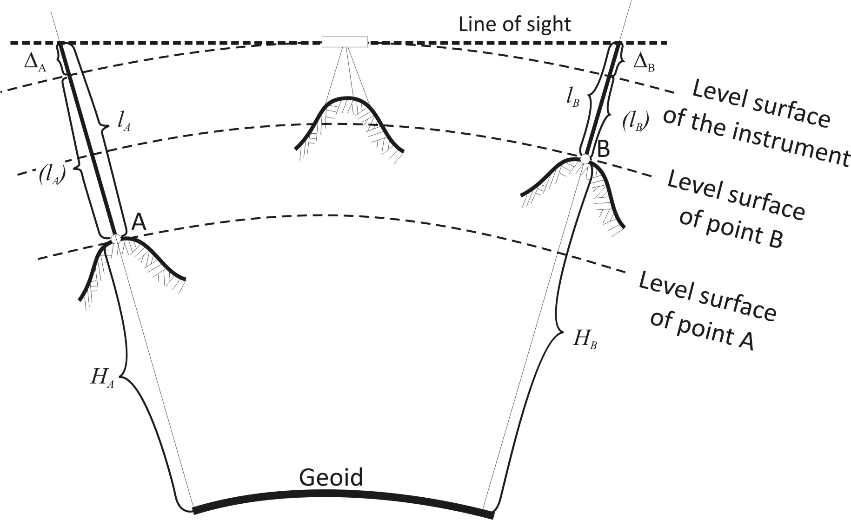

Figure 2-1 The principle of levelling

Since the line of sight is a straight horizontal line, the observations taken with the instrument are:

$l_{A}=\left(l_{A}\right)+∆_{A}$, and $l_{B}=\left(l_{B}\right)+∆_{B}$,

where Δ_{A} and Δ_{B} are the effect of the curvature of the level surfaces. In case of small areas, the level surface can be approximated by a spherical surface. Assuming that the horizontal distance between the instrument and the staff at point A and point B are the same, then Δ_{A}=Δ_{B}. Thus the elevation difference becomes:

$$∆H_{AB}=\left(l_{A}\right)-\left(l_{B}\right)=\left[l_{A}-∆_{A}\right]-\left[l_{B}-∆_{B}\right]=l_{A}-l_{B}.$$

Remarks: Let’s note the following convention: elevation difference is always denoted with two indices. The first index identifies the reference point, while the second identifies the point, of which the elevation difference should be determined relative to the reference point. On Fig. 2-1. the reference point would be point A, and the elevation difference ΔH_{AB} is positive. Please also note that by inverting the indices, the elevation difference is inverted, too. Thus ΔH_{BA} would have the same absolute value as ΔH_{AB}, but it would be negative in this case.

The principle of line levelling
When point A and point B are far from each other, and the staffs placed at the two points are not intervisible, then ‘line levelling’ should be carried out. In this case some additional points are measured between the two endpoints A and B, thus the elevation difference between A and B is broken apart to many elevation differences. The aforementioned additional points are called the change points. Change points are usually marked temporarily with a ‘change plate’. This plate has a hemispherical top surface to enable the exact turning of the staffs without any vertical displacement.
Assuming that the horizontal distances between the instrument and the staffs are identical, the effect of the curvature of the level surfaces is eliminated. Moreover, since the instrument-staff distance is relatively short (up to 20-30 metres), the level surface can be approximated by a horizontal plane. Such a levelling line can be seen on Fig. 2-2.

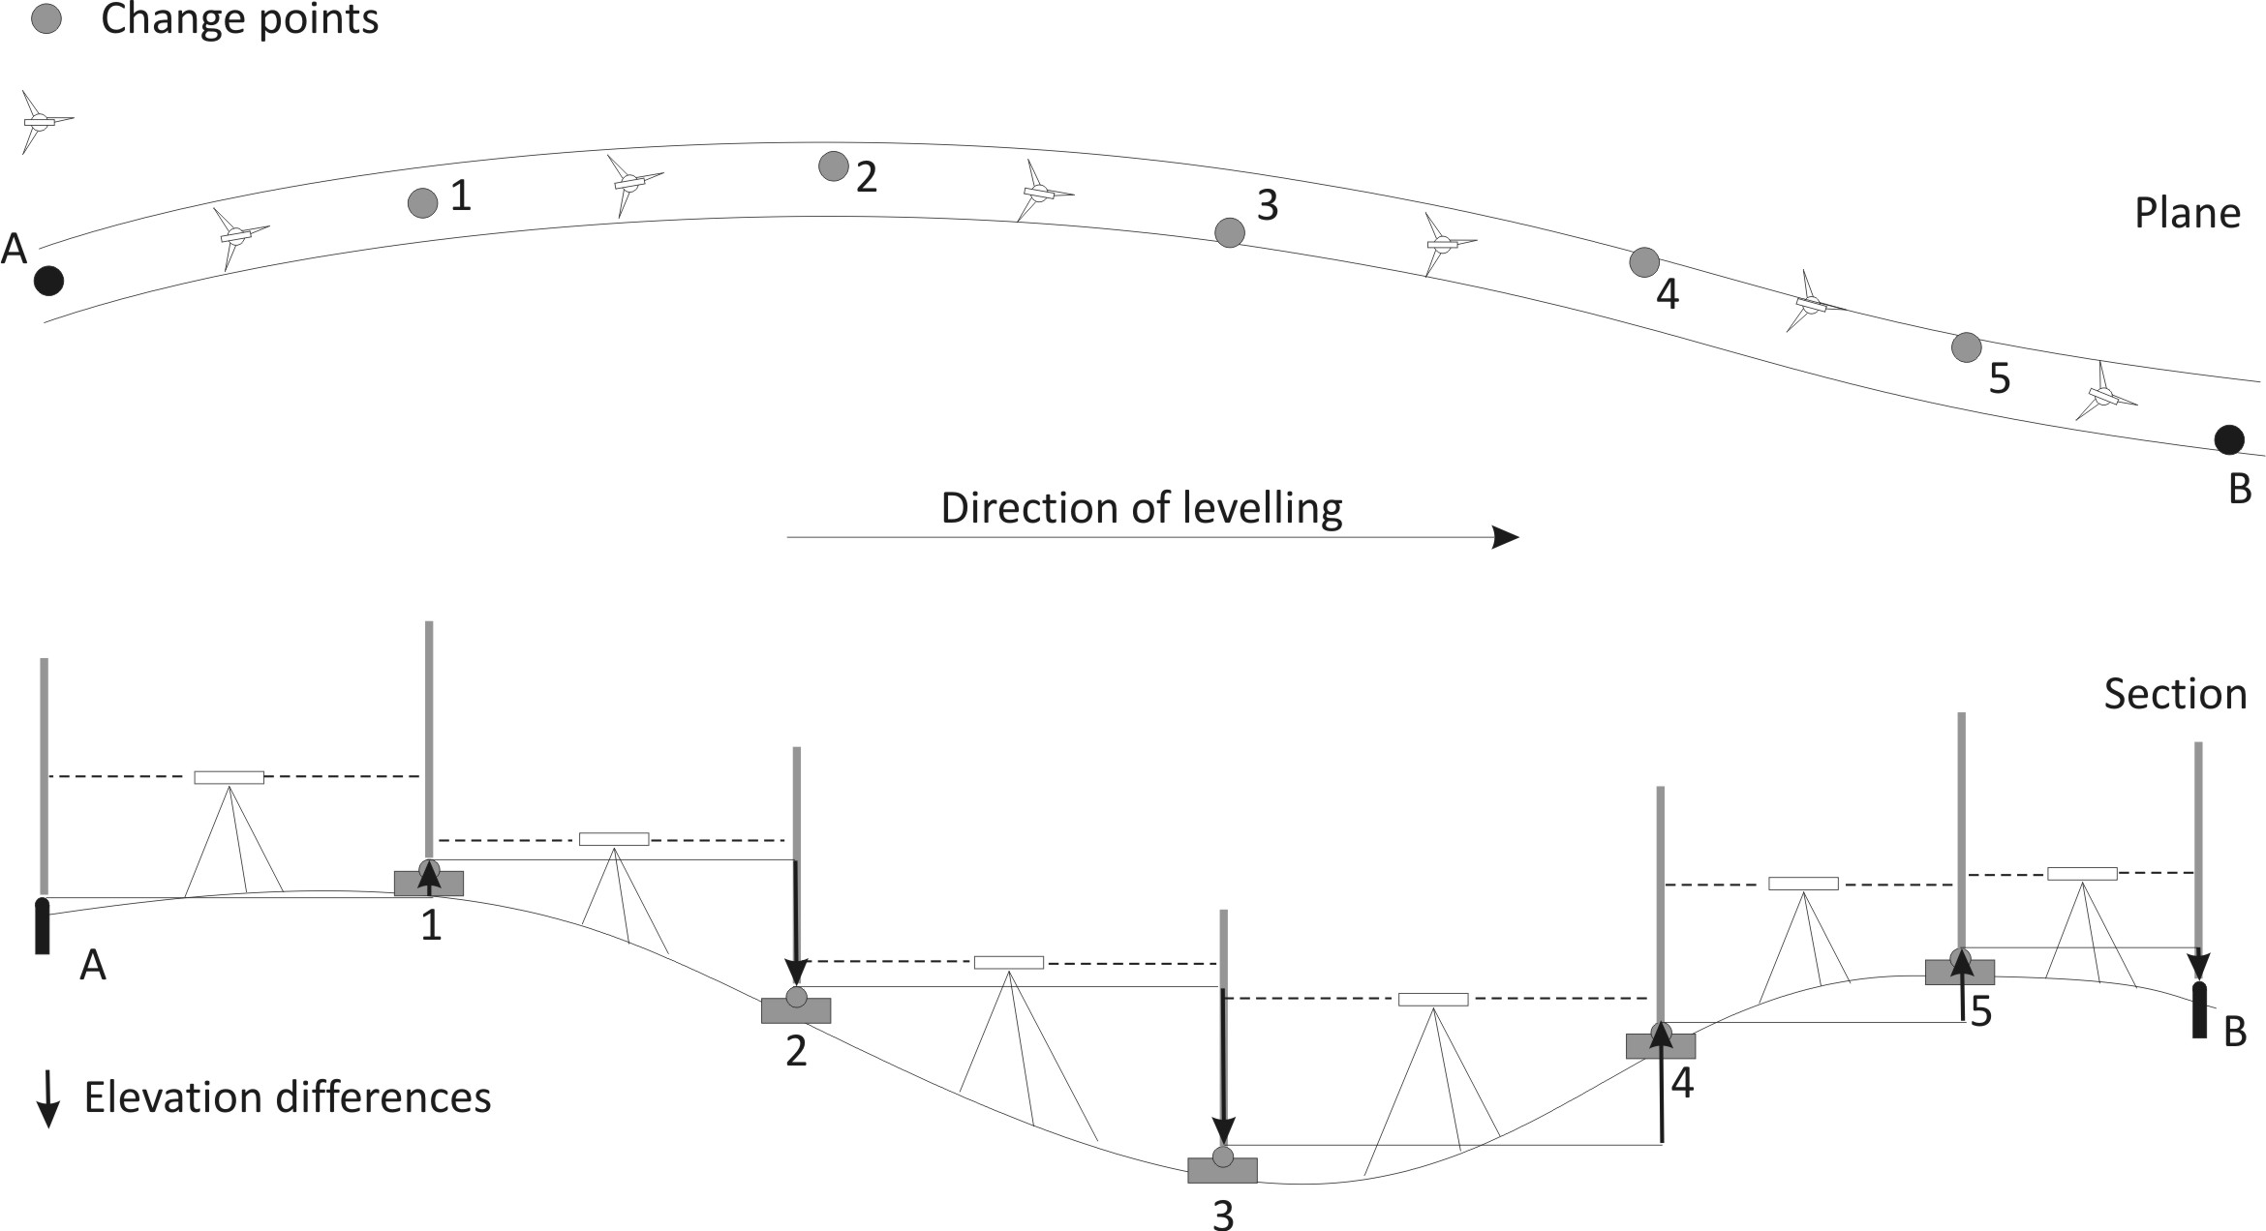

Figure 2.2 Line levelling. The elevation difference between A and B is measured in many sections.

Since the distance between A and B is too large to be able to measure the elevation difference directly, altogether 5 change points have been established in the line. Thus 6 elevation differences are computed using the readings on the graduated staffs. The elevation differences can be computed in the following way:
$$∆H_{A1}=l_{A}^{BS}-l_{1}^{FS},$$
$$∆H_{12}=l_{1}^{BS}-l_{2}^{FS},$$
$$∆H_{23}=l_{2}^{BS}-l_{3}^{FS},$$
$$∆H_{34}=l_{3}^{BS}-l_{4}^{FS},$$
$$∆H_{45}=l_{4}^{BS}-l_{5}^{FS},$$
$$∆H_{5B}=l_{5}^{BS}-l_{B}^{FS}.$$
where the superscript BS is the abbreviation of ‘backsight’ reading and FS is the abbreviation of ‘foresight’ reading. Backsight reading means that the reading is taken on a staff, which is in the opposite direction to the direction of the levelling, while foresight is a reading on a staff, which is in the same direction as the direction of the levelling.
The total elevation difference between A and B is:
$$∆H_{AB}=\sum{∆H_{i}}=\sum{l_{i}^{BS}}-\sum{l_{i}^{FS}}.$$
Thus the elevation difference between the two endpoints of the line levelling can be computed by subtracting the sum of the foresights readings from the sum of the backsight readings.

The surveyors’ level
There are three types of levels, which are used by the surveyors: the tilting levels; the automatic levels; and the digital levels. In the next sections the various instruments will be introduced.

The elements of the surveyors’ level
The most important characteristic of the surveyors’ level is that the instrument has a line of sight, which is tangential to the level surface. This tangential line of sight can be achieved by many ways. It is either achieved by setting a bubble tube to horizontal position, which is mounted parallel with the line of sight, or an automatic device sets the line of sight to the horizontal position. Since the automatic device – called the compensator – can compensate for a limited tilting, an approximate levelling of the instrument must be done before the observation. Therefore it is necessary to have a bubble tube or circular bubble on these instruments, too.
On the other hand the instrument should be able to create a line of sight. For this purpose a telescope is needed, which is called the surveyors’ telescope. Let’s see the basic features of these elements!

The bubble tube
The bubble tubes are ground to a circular profile in the longitudinal section (Fig. 2.3). They are closed tubes, filled almost totally with alcohol to avoid freezing. Only a small amount of air is left in the tube to form a bubble. Since the bubble tends to move to the topmost part of the tube, it can be used to make an axis horizontal.
The top surface of the bubble is graduated. The long graduation lines correspond to the size of the bubble at the normal temperature. Since the instrument should be used at colder and warmer temperatures as well, the graduations continue inwards and outwards, too. Since the bubble moves always to the topmost part of the tube the tangential drawn to the centre of the bubble is always horizontal.
The sensitivity of the bubble tube is defined by the amount of the displacement of the bubble due to a certain amount of tilting of the tube. Thus the value of the sensitivity depends on the radius of the tube. The larger the radius is, the more sensitive the bubble tube becomes (Fig 2.4).

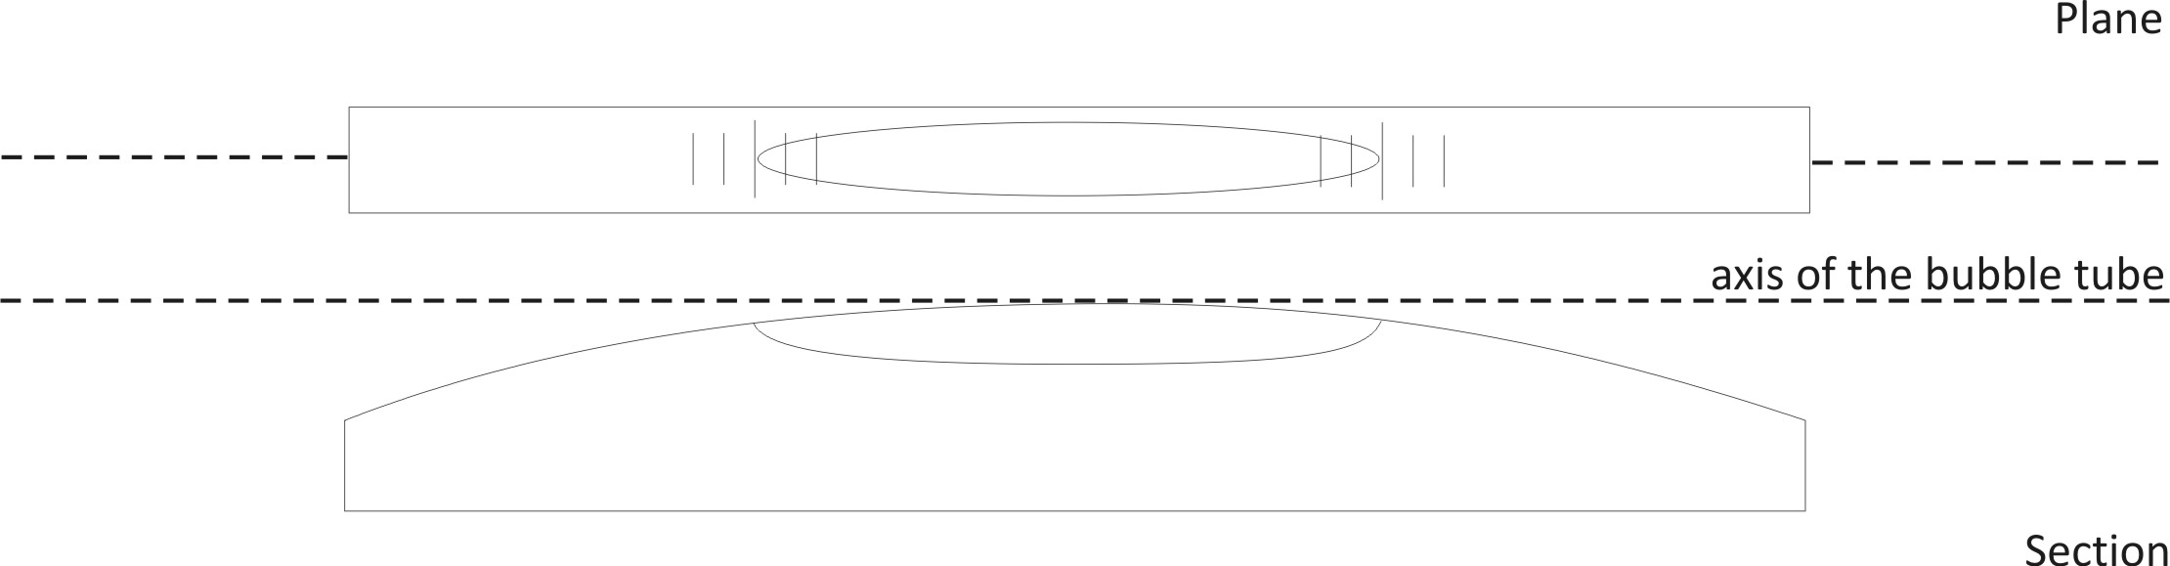
Figure 2.3 The bubble tube

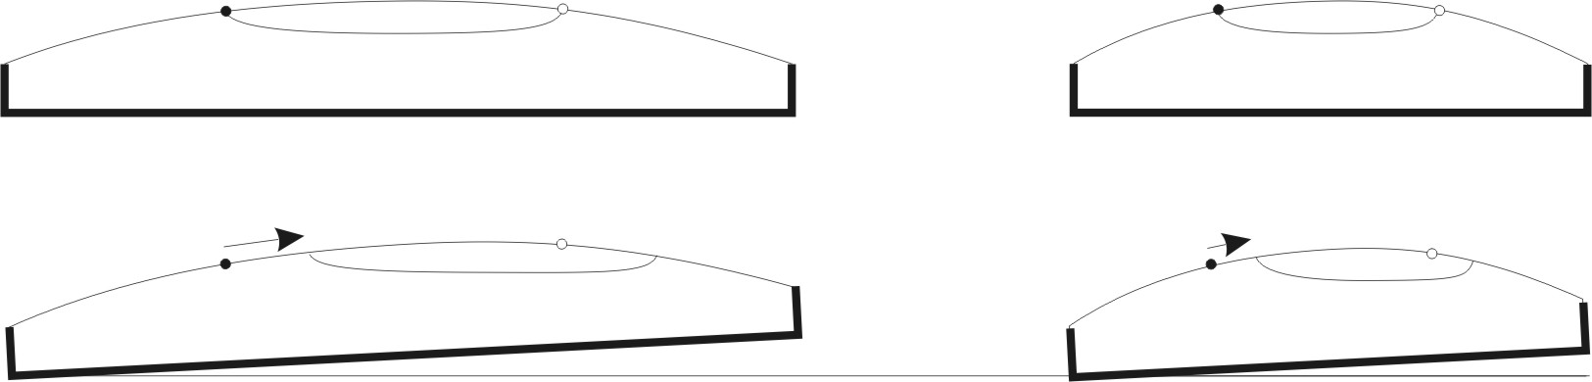

Figure 2.4 The sensitivity of the bubble tube depends on its radius

The surveyors’ telescope
Telescopes are used to watch distant objects magnified. A Kepler-type telescope (Fig 2.5) contains two lenses. The object lens is the one closer to the object (T), while the eyepiece (also known as ocular) is where one can watch the telescope’s image. The objective first creates an inverted real image of the object (T’), while the eyepiece creates a magnified virtual image of the real one (T’’). The magnification is one of the most important properties of the surveyors’ telescope, since the resolution of the telescope depends on the magnification.
However the surveyors’ telescope (Fig. 2.6) must be distinguished from the Kepler-type telescopes. Since a visible line of sight is also needed, therefore the surveyors’ telescope contains an additional element, called the diaphragm. The diaphragm (Fig 2.7) is located within the telescope and consists of at least two crosshairs, the horizontal and the vertical crosshairs. In many telescopes the diaphragm contains ‘stadia hairs’ as well. These stadia hairs (stadia lines) are used to measure the distance of the objects from the instrument. The intersection of the horizontal and vertical crosshairs and the optical centre of the object lens define the line of collimation (also known as line of sight) of the instrument (Fig 2.6).

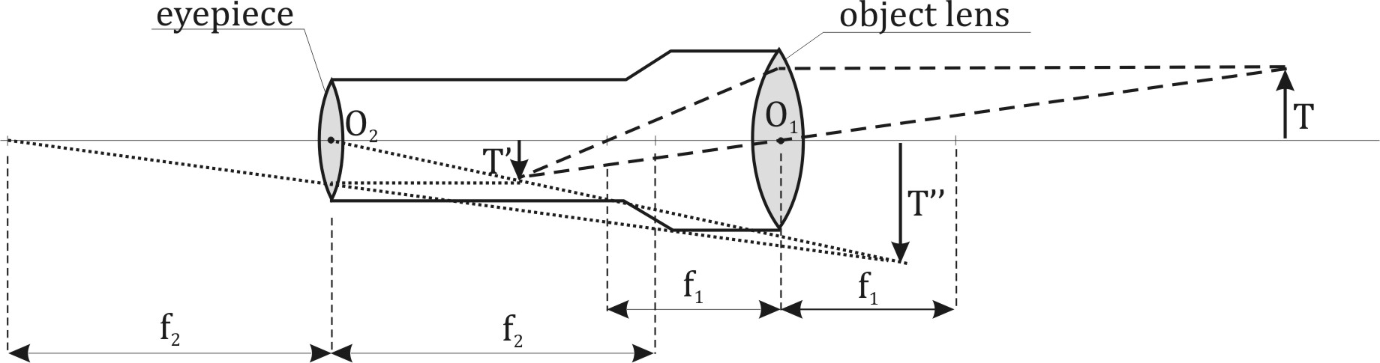
Figure 2.5 The Kepler-type telescope

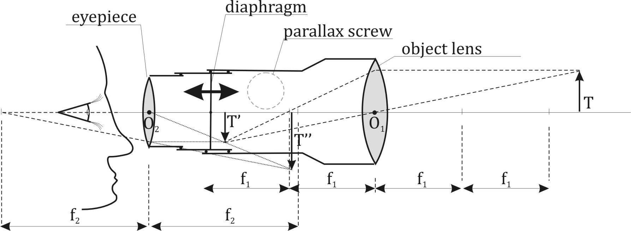
Figure 2.6 The surveyors’ telescope with external focusing

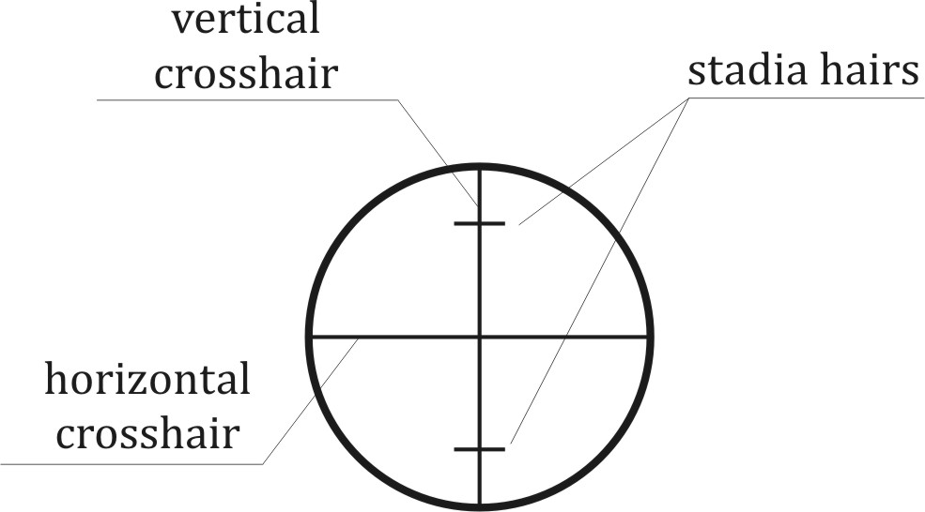
Figure 2.7 The diaphragm

In the surveyors’ telescope the distance of the real image of the object (T’) from the object lens may vary between f₁ and 2f₁, where f₁ is the focal length of the object lens. An object in an infinite distance from object lens creates a real image in the distance of f₁, while another object in the distance of 2f₁ creates the real image in the distance of 2f₁.
Please also note that it is impossible to sight a target, which is closer to the object lens than 2f₁, since in this case the real image would be created outside the working area of the diaphragm, or when the object distance is shorter than the focal length of the object lens, then no real image is created by the lens. This distance of 2f₁ is called the close point of the telescope and has the value of approximately 2 metres.

The parallax
Since the virtual image of the object (T’’) and the virtual image of the diaphragm should both be in focus during the observations, the distance of the diaphragm from the object lens can be changed between f₁ and 2f₁ using the – so called – parallax screw. What happens when the diaphragm and the real image of the target is not aligned in the same plane? This phenomenon is called the parallax.
When parallax occurs, then the readings on the staff depend on the position of the eye (Fig. 2.8). By moving the observer’s eyes up and down, the readings on the staff changes. Since a reading must not depend on the position of the observer’s eyes, therefore the parallax must be removed before the reading. Removing the parallax means that the real image of the staff and the diaphragm must be in the same plane, which is orthogonal to the line of sight.

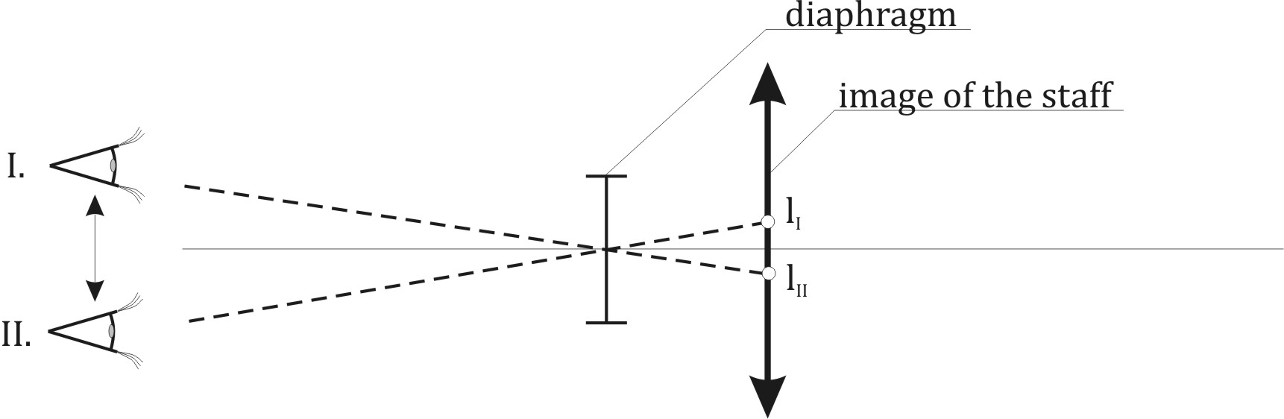
Figure 2.8 The effect of the parallax

External focusing
In case of external focusing, the telescope consists of three different parts (Fig 2.6). The tube of the eyepiece contains the eyepiece. This tube can be moved within the tube of the diaphragm, while the tube of the diaphragm together with the tube of the eyepiece can be moved in the object tube. Before taking the first reading on the staff, the various parts of the telescope should be set correctly. Firstly a light background should be sighted (a plain paper sheet) and the tube of the eyepiece should be moved within the tube of the diaphragm until the crosshairs are focused. Since the users have optically different eyes, therefore everyone should set the telescope according to his/her personal needs.
After sighting the staff one should remove the parallax. In case of parallax one sees only the crosshairs focused, not the image of the staff. Therefore the diaphragm tube together with the eyepiece tube should be moved in the object tube to align the diaphragm with the real image of the staff. Since the view of the diaphragm is focused, in this case the staff should be focused, too. When both are focused then the parallax is removed and the readings are not contaminated by the effect of the parallax.
Please note that the length of the telescope changes according to the distance of the target.

Internal focusing
Due to the improvement of the optical industry, a modernized surveyors’ telescope was designed with internal focusing. In this case the telescope consists of two tubes. One of them is the eyepiece tube, which can be moved in the object tube. The diaphragm is fixed in the object tube. By adjusting the position of the eyepiece tube to our eyes, the image of the crosshairs is in focus. However the real image of the object is not aligned with the diaphragm, yet (see the grey arrow on Fig. 2.9). In order to achieve this, the telescope contains an internal focusing lens (a concave lens), which can be moved within the object telescope. By moving this lens with the parallax screw, the real image of the object and the diaphragm can be aligned (see the black arrow pointing downward aligned with the diaphragm).
The advantage of the internal focusing is that shorter and more robust telescopes can be built. On the other hand the additional lens does not cause significant deterioration of the image quality of the telescope.

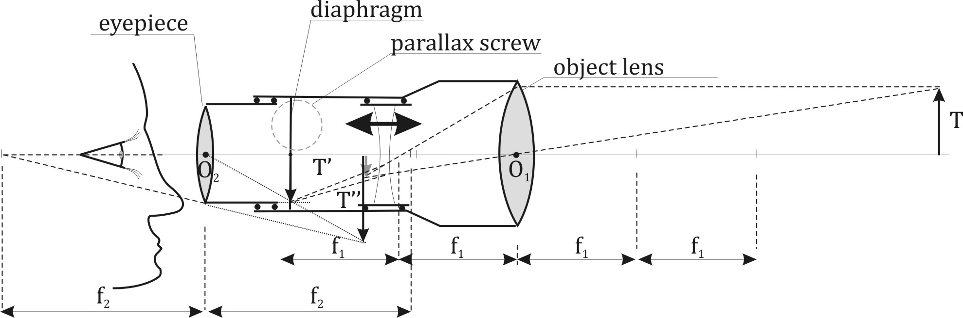
Figure 2.9 Surveyors’ telescope with internal focusing

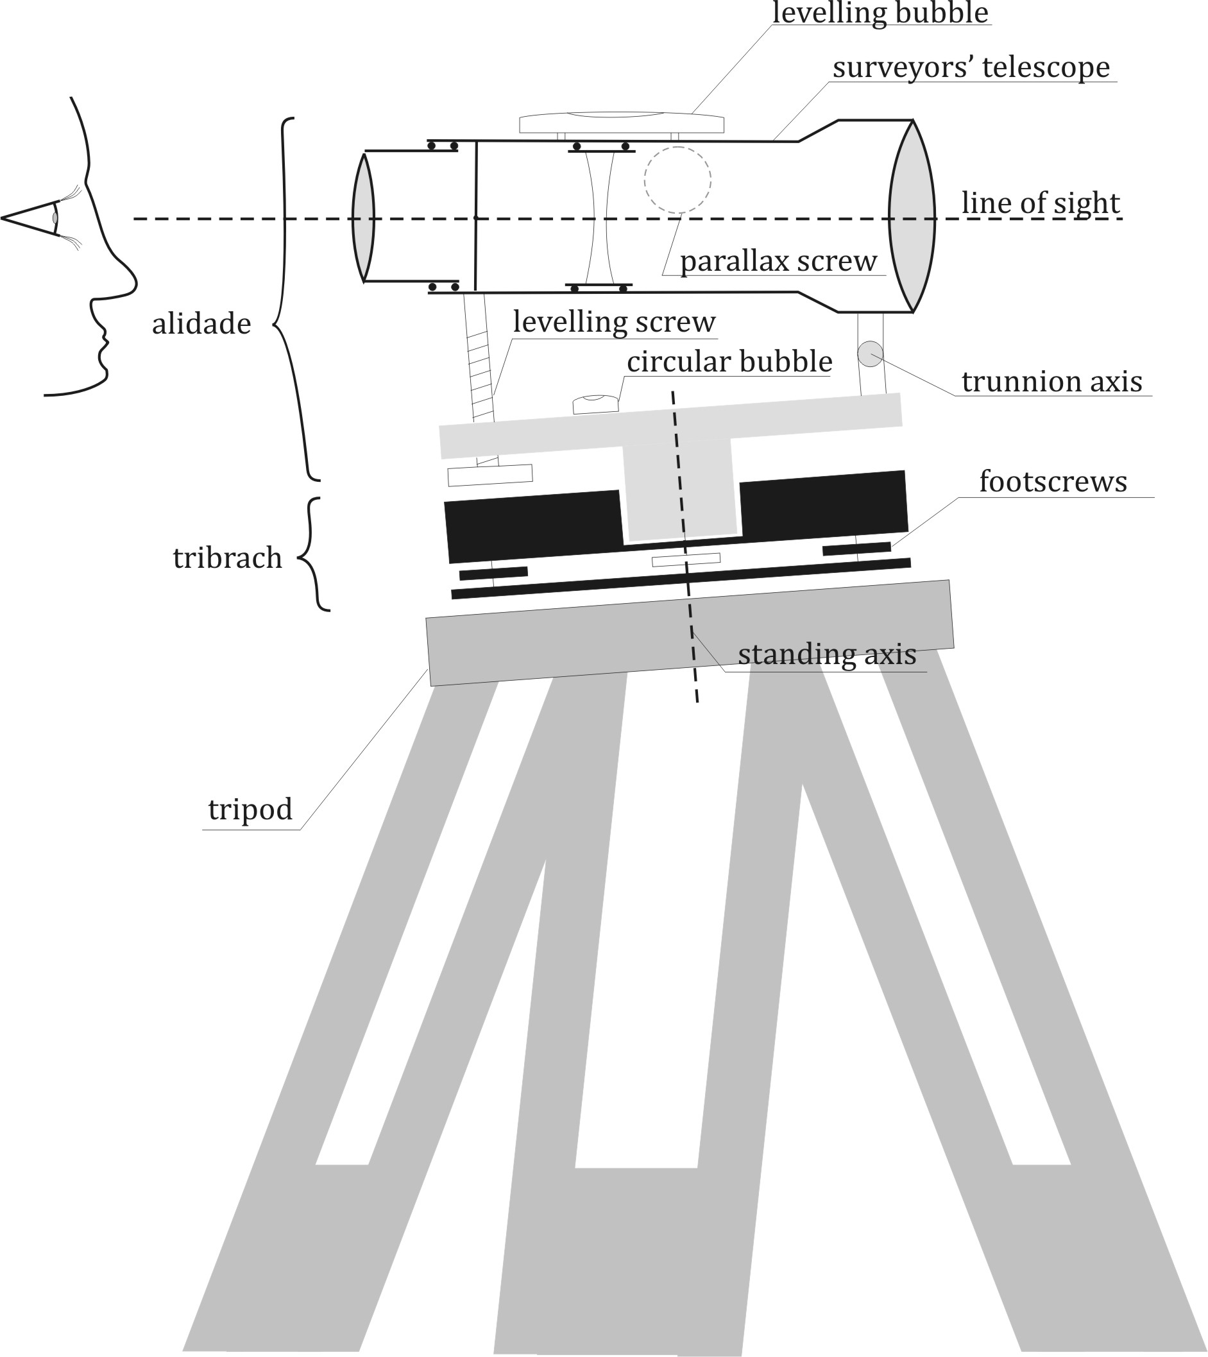

Figure 2.10 Tilting level mounted on a tripod.

The tilting level
The structure of the tilting level can be seen on Fig. 2.10. The instruments used in surveying are usually fixed to a tripod. Since the length of its legs can be adjusted to different values, tripods can be set up on any terrain so that the head would be approximately horizontal.
The tilting level is mounted on the tripod with a fixing screw. Let us have a look at the structure of the tilting level in more detail.
The instrument consists of two main parts. The tribrach contains the three footscrews. The alidade is the upper part of the instrument, which can be revolved around the standing axis to any horizontal direction. The tribrach is used to level the instrument approximately. In order to do this, one can find a circular level on the alidade or on the tribrach itself. Since this circular bubble is not sensitive enough to set the line of sight in a proper horizontal position, a bubble tube is mounted on the top of the telescope. This bubble tube is called the ‘levelling bubble’.
In order to set up the instrument, the tribrach should be levelled by the footscrews. To do this quickly, two principal directions should be chosen according to Fig. 2.11. The first principal direction is always aligned with two arbitrarily chosen footscrews, while the second one is perpendicular to the first one. By rotating the two footscrews in the first principal direction in an opposite way, the circular bubble can be moved parallel with this direction to the center line. Afterwards only the third footscrew should be rotated to move the bubble parallel with the second principal direction to the exact center of the circular bubble. The direction of the rotation can be identified by the rule of the ‘left thumb’. During the rotation of the footscrews, the movement of the left thumb shows the direction of the movement of the bubble (Fig 2.11)

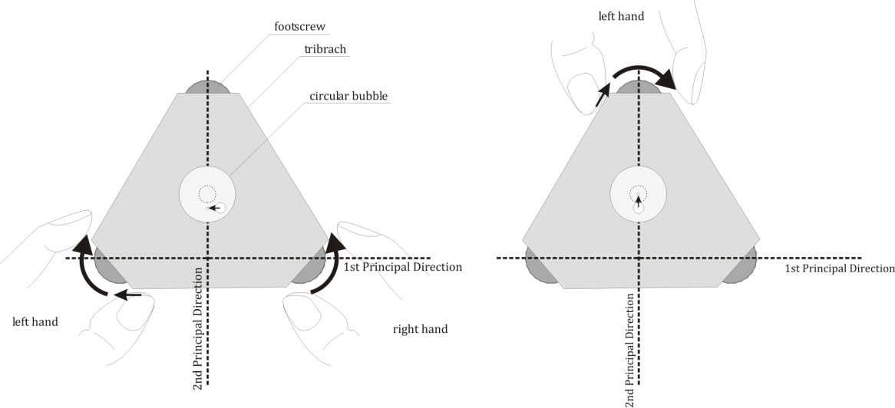
Figure 2.11 Levelling the instrument with the footscrews

When the circular bubble is set to the centre, the instrument is approximately levelled. It means that the instrument has only a small remaining tilting, which can be easily adjusted with the help of the levelling bubble.
After setting the circular bubble, the staff should be sighted. To fix the telescope in the direction of the staff, the horizontal clamps can be used. After fixing the alidade, the sighting can be slightly improved by the fine motion screw, which is used to finely revolve the alidade around the standing axis.
In order to adjust the line of sight to a horizontal position, the levelling bubble (which has an axis exactly parallel with the line of sight) should be centred with the help of the levelling screw. By rotating the levelling screw, the telescope is tilted around the trunnion axis (which is approximately horizontal) until the levelling bubble reaches the centre. Since the axis of the bubble tube is parallel with the line of sight, now the line of sight becomes horizontal. Thus the instrument can be used for levelling. In the next step the reading eyepiece must be adjusted to the eye of the observer. By rotating the adjusting screw of the reading eyepiece, the diaphragm must be focused. Afterwards the parallax is removed (the image of the staff is focused) with the parallax screw. Finally the readings can be taken on the graduated staff.
It must be noted that the horizontal line of sight is achieved only in the direction of the telescope. Since the standing axis has some remaining tilting, the line of sight tilts when the alidade is revolved around the standing axis. Thus the levelling bubble must be set before each reading on the staff.

The automatic level
One of the major drawback of the tilting level is the need for the adjustment of the levelling bubble before each staff reading. This procedure is not only time consuming, but it may cause blunders (big mistakes) in the readings, when the observer forgets to set the levelling bubble. In order to avoid this disadvantage, the automatic levels have been developed by the instrument manufacturers.
The automatic level contains an additional prism hanging on a pendulum, called the ‘compensator’. The compensator can set the line of sight in a horizontal position automatically, even when the standing axis is tilted a little bit (a few arcminutes of tilting is acceptable). When the instrument is levelled using the circular bubble, then the compensator hangs in a vertical direction due to the gravity vector and compensates for the tilting of the standing axis, thus the horizontal line of sight is created.
Thus the automatic level has a slightly different structure compared to the tilting level. Since the line of sight is set automatically after levelling the instrument, the levelling bubble, the levelling screw and even the trunnion axis are not needed anymore.
Automatic levels are easier to handle. However in an environment where vibration may occur, the pendulum starts to swing, thus the line of sight oscillates along the horizontal position. Such a vibration can be caused by vehicles and machinery operating in construction sites or even wind can lead to the vibration of the instrument. When heavy vibration occurs, the image of the staff becomes blurred, thus no readings can be taken with these instruments.
In such an environment the traditional tilting levels can be used.

Engineering levels and precise levels
Both the tilting and the automatic levels can have different precision. In the everyday construction practice the engineering levels are used. These instruments are compact instruments with a short telescope. Thus the angular magnification of the telescope is smaller compared to the precise levels.
In case of the engineering levels the readings are directly taken using the horizontal crosshair. The precision of a 1 km long two-way line levelling for an engineering level is in the order of 2 mm.
Precise levels contain additional optical element to increase the accuracy of the staff reading. Using a micrometer screw and a plan-parallel glass plate the image of the staff can be shifted in order to set a graduation line on the staff to the same level as the horizontal crosshair. Since graduation lines are usually placed in every centimetre, therefore the readings are combined from the staff reading (up to the centimetre digit) and the position of the micrometer screw (up to the level of one hundredth of a millimetre). Precise levels nowadays have the precision of approximately 0.3-0.4 mm/km for two-way levellings.

The adjustment of the tilting level
The principle of levelling assumes that the surveyor’s level creates a horizontal line of sight. In order to ensure the validity of this assumption, the instruments must be regularly checked and calibrated. The proper operation of the tilting level can be checked on the field using the following procedure.
Let’s assume that the axis of the levelling bubble and the line of sight is not parallel. In this case a tilted line of sight is created, when the levelling bubble is centered. This tilting angle (α) is called the ’collimation error’.

The adjustment of the alidade bubble
When the alidade bubble (circular bubble) is adjusted and it is centered, then the standing axis is approximately vertical and the levelling bubble can also be centered with the levelling screw in any directions. Thus the horizontal line of sight can be ensured in any directions.
The alidade bubble can be adjusted according to the following procedure. Firstly the standing axis must be set in a vertical position using the levelling bubble. Since no graduation is made on the surface of the levelling bubble, the levelling bubble must be centered with the levelling screw and the position of the levelling screw must be noted (p₁). Then the alidade is revolved around the standing axis by 180° and the levelling bubble is centered with the levelling screws. Let’s denote the position of the levelling screw with p₂ in this case.
The levelling screw is set to the middle position:
.
Afterwards the levelling bubble is centered using the footscrews in the first and in the second principal direction, similarly to the approach shown in Fig. 2.11. Thus the standing axis is vertical. When the alidade bubble is not centered, then this must be adjusted using the small adjusting screws adjacent to it.
Thus the alidade bubble is checked and adjusted. Therefore the standing axis can be set to the local vertical using the alidade bubble afterwards.

The determination of the collimation error – the two-peg test
One can create a horizontal line-of-sight with a tilting level by setting the levelling bubble to the center. However this works only, when the axis of the levelling bubble and the line-of-sight is exactly parallel.
In the following step of the adjustment procedure one must align the axis of the levelling bubble parallel to the line-of-sight of the instrument. It must be noted, that a misalignment leads to a tilted line-of-sight, which eventually degrades the observations accuracies in some cases.
In order to determine the collimation error, a suitable test baseline must be created. This baseline can be established on the construction area using two pegs with a nail in the middle, too (Fig. 2.12).
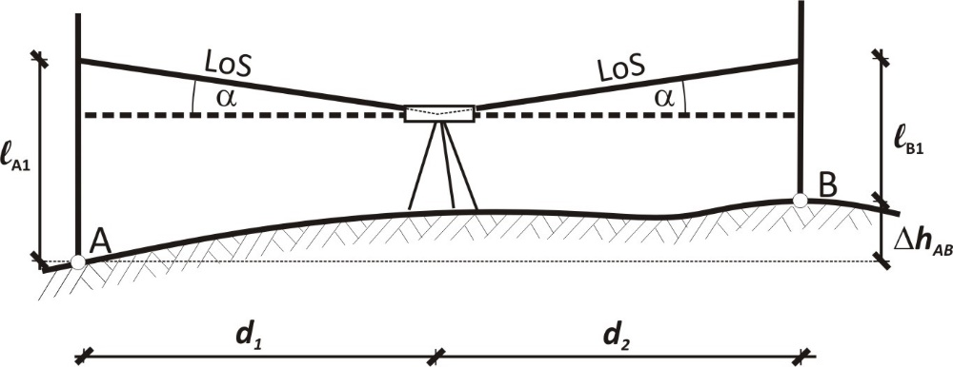

Figure 2.12 Two-peg test (measurements from the center)

The first task is to measure the proper elevation difference between the two pegs. Since it is assumed that the instrument has a collimation error, therefore the tilting level must be set up exactly in the middle of the baseline, thus the instrument-staff distances become equal. Due to the fact that the collimation error provides a constant tilting angle of the line of sight, the effect of the collimation error on the staff readings are the same for both of the staves A and B:

.

Let’s denote the readings taken along the real (tilted) line-of-sight with a₁ and b₁. Thus the true elevation difference of the two pegs can be computed as:

Since the instrument was set up in the middle of the baseline, d₁=d₂. Thus the effect of the collimation error is eliminated from the elevation difference, and it can be computed as:

Please note that the collimation error could be eliminated by maintaining the same instrument-staff distance for both of the readings.
When the proper elevation difference of the two pegs is known, then the collimation error (α) can be computed from the observation of the same elevation difference from an external point of the baseline (Fig. 2.13.).

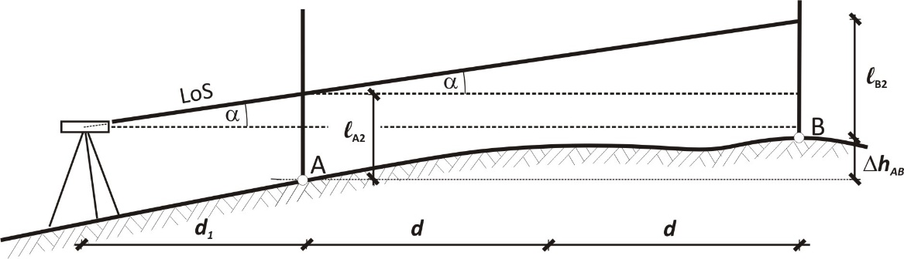

Figure 2.13 Two-peg test (observations from an external point)

Let’s denote the staff readings with l_{A2} and l_{B2} in the second case and let’s assume that the instrument was set up in a distance of d₁ from the closer staff. The true elevation difference of the points can be computed as follows:

Please note that the term d₁tanα cancels out. It means that the distance between the instrument and the closer staff can be chosen arbitrarily. One must take into consideration the focal distance of the instrument only.
Since the true elevation difference is already known from the first set up, the collimation error can be expressed as a function of the staff readings and the length of the baseline:

.

Adjustment of the levelling bubble
When the collimation error is determined, the adjustment of the levelling bubble must be done according to the following procedure. The instrument is set up in a known distance from a staff. The levelling bubble is centred, thus a tilted line of sight is created due to the collimation error. When the staff reading (l) is taken, it can be corrected for the effect of the collimation error with the following equation:

,

where l is the staff reading along a perfectly horizontal line of sight. The line of sight can be set to this reading by rotating levelling screw, thus adjusting the line of sight in a horizontal position. Due to the collimation error, the levelling bubble moves off the center. Finally it must be re-centred by the adjusting screws of the bubble tube.
Thus the levelling bubble is adjusted, which means that its axis is exactly parallel with the line-of-sight of the instrument.

Systematic error sources of levelling
The systematic error sources have a systematic effect on the observations, thus they cannot be eliminated by repeating the observations many times. Moreover these error tend to accumulate in line levelling, since the total elevation difference of the endpoints is computed as a sum of elevation differences observed in the individual stations.
In order to avoid the accumulation of systematic error, one must be aware of the sources and suitable observation procedures must be followed to eliminate their effects on the levelling observations.

The effect of curvature
In the introduction of the principle of levelling it has been already noted that the surveyors’ level creates a horizontal, ‘straight’ line-of-sight, instead of reproducing the equipontential surface of Earth’s gravity field in the vicinity of the instrument. Thus the staff readings are contaminated by the effect of the curvature of the equipotental surfaces Δ_{A} and Δ_{B} (see Fig. 2.1). It was concluded, that the instrument should be set up in the same distance from the two staves. In this case – when the equipotential surfaces of the gravity field are approximated by spheres in the vicinity of the instrument – the effect of curvature on the staff readings will be identical for the backsight as well as for the foresight reading.
Since the elevation difference is computed as the difference of the staff reading, the effect of curvature is eliminated from the computed elevation differences.

Instrumental error sources

The collimation error
The collimation error means that the line-of-sight of the tilting level is not in a horizontal position, when the levelling bubble is centred. Due to this effect the staff readings differ from the proper readings taken along the horizontal line.
It was already discussed in the previous sections (see the two-peg test), that the effect on the staff reading depends on the instrument-staff distance. Thus by applying the same instrument-staff distance for both the backsight and the foresight staff, the effect of the collimation error can be eliminated from the elevation differences.
It must be noted that a collimation error can be caused by the misalignment of the levelling bubble. However a similar error occurs, when an uneven strong heat radiation affects the levelling bubble (e.g. sunlight). In this case the liquid inside the bubble heats up, which moves the bubble off the centre in case of horizontal line of sights. Therefore the instrument must be protected from direct sunlight to avoid this effect.

The compensator error
This error may accumulate during the line levelling carried out by automatic levels. Compensator error means that the compensator does not compensate for the tilting of the standing axis, thus it creates a slightly tilted plane instead of a horizontal one, when the instrument is rotated along its standing axis.
The error might accumulate, when the standing axis is always levelled in the same direction. In order to eliminate this error source, one should take the staff readings in a backsight-foresight order and repeat them in the foresight-backsight order. The standing axis must be levelled in an ‘object lens forward’ manner before the first pair of the readings, and it must be re-levelled in an ‘object lens backward’ manned before the second pair of the readings.
When the elevation differences are computed from the first pair of the readings and a second pair of the readings, the effect of the compensator error has a different sign in the elevation differences (Fig. 2.15.), thus it can be eliminated by computing the mean value of the elevation differences of the two pairs of the readings.

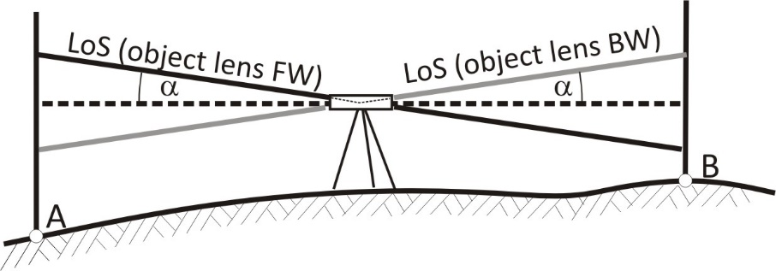

Figure 2.15 The effect of the compensator error for automatic levels

Excentricity of the tilting axis
This error source might affect the observations of the tilting level. Since in the engineering class tilting levels contain a tilting axis which has a horizontal offset from the standing axis (Fig. 2-16), this can lead to a change in the level of the instrument between the backsight and the foresight readings. In order to avoid or better to say to minimize this effect, the standing axis must be carefully levelled at each station.
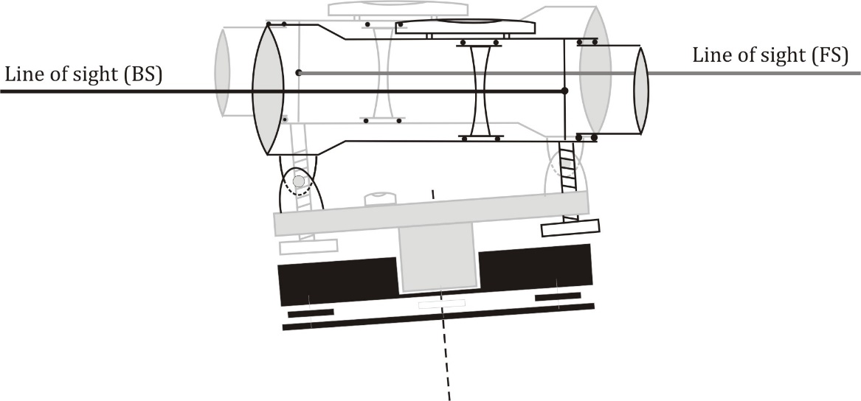
Figure 2.16 The effect of the excentricity of the tilting axis

Error sources induced by the staff

Tilting of the staff
It is always assumed that the staff is placed in a vertical position, when the readings are taken on them. However it should be investigated, how the tilting of the staff changes the staff reading.
Let’s assume that the staff is tilted by 2° with respect to the vertical position. The staff reading would be 3450 (3m and 450 mm). How is this reading changed due to the tilting of the staff?
It can be computed using the Figure 2.17:

Thus it can be seen that a small tilting of the staff can lead to an error in the order of 1 millimetre. In order to avoid this error, all of the staves must be equipped with circulat bubbles and they need to be set properly in a vertical position during the observations.

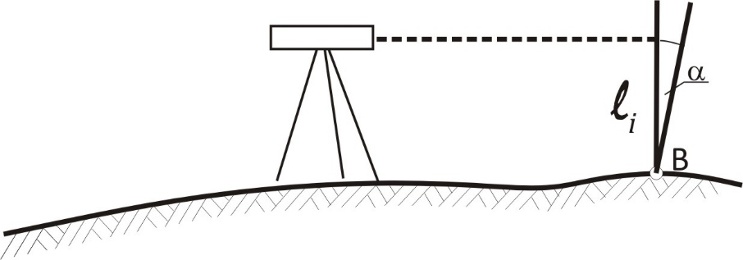

Figure 2.17 The tilting of the levelling staff

Graduation error of the staff
The principle of levelling defined the staff reading as the distance between the line-of-sight and the bottom of the staff. However it is true only, when all of the graduation lines have the same and proper length. In case of engineering staves, all of the graduation lines must have the length of 1 cm. When one graduation line has a different length, all of the readings above this line – and only these readings – are deteriorated by this error.
In order to eliminate this error, the staves must be calibrated regularly. During this calibration process the length of the graduation lines are checked and a correction table is created, which could be used for correcting the staff readings during the processing of the observations.

Index error of the staff
Another problem of the graduation of the staff occurs, when the index (the 0 graduation) does not coincide with the bottom plane of the staff. When this happens, then all of the staff readings are either smaller or bigger than the real distance between the line-of-sight and the bottom of the staff.
The effect of the index error can be given as:
,
where (l) is the staff reading contaminated by the index error, δ is the index error and l is the real distance between the line-of-sight and the bottom of the staff.
How does this error affect the observed elevation differences? Let’s examine two cases.
In the first case a single staff is used in the levelling, thus both the backsight and the foresight readings are affected by the same index error. In this particular case the effect of the index error cancels out, since the elevation difference (Δh) can be computed as a difference between the two staff readings:

,

where (l_{BS}) and (l_{FS}) are the backsight and the foresight readings respectively.
However in most cases surveyors use two staves to increase the speed of the observations. In this case it is unavoidable to use two staves with different index error values. Let’s see how the different index error values influent the elevation differences! The single elevations difference can be written with the following formula:

.

Thus the relative index error of the two staves contaminates the elevation difference. Let’s consider two consecutive stations, where the second staff remains at the same change point, and the first staff becomes the foresight staff at the second station. Please note that the order of the staff is different at the stations. The second elevation difference becomes:

.

The relative index error is still present in the elevation difference, but the signs change. By adding up the previous two equations, it should be noted that the index error is eliminated.
Due to the previous reasoning it can be stated, that the index error can be eliminated after every second station when two staves are used. Let’s put it differently. The index error can be eliminated in line levelling by creating an even number of stations along the levelling line when two staves are used. When a single staff is used along the levelling line, the index error is eliminated automatically from the elevation differences.

Error sources induced by external conditions
Unfortunately external factors affect the accuracy of the observations, too. Such external effects are:
- atmospheric conditions;
- settlement of the tripod due to the consolidation of the soil underneath;
- settlement of the staff due to the same reason.

Atmospheric effects
Due to the fact that the physical conditions of the atmosphere changes in space and time, the propagation velocity of light changes accordingly. The propagation velocity is mainly dependent on meteorological parameters like ambient temperature, air pressure and humidity. Generally the colder the air is to lower the propagation velocity becomes (since the air gets denser). With similar reasoning a higher air pressure leads to lower propagation velocity, too.
It is well known from Snell’s law that light is refracted at the interface of two neighbouring medium, which have different optical properties (propagation velocities or refractive indices are different).

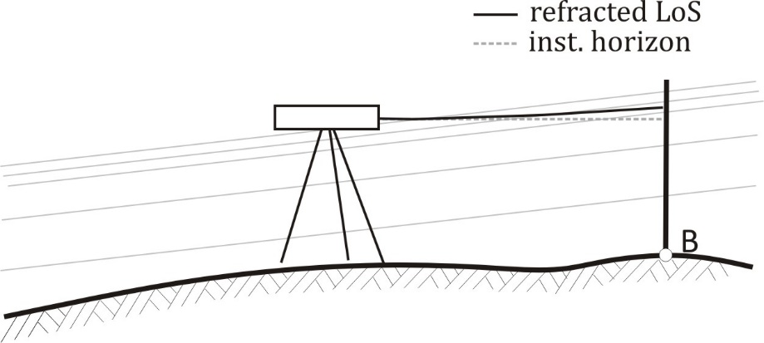

Figure 2.18 The effect of refraction

Since the meteorological parameters – and consequently the refractive index – changes along the line-of-sight, it is continuously refracted. Thus the line-of-sight is not a straight line in reality, but it is slightly bent due to the atmospheric refraction (see Fig. 2.18).
This bending definitely has an effect on the staff readings. In order to quantify this effect, the refractive curve (e.g. the bent line-of-sight) can be approximated by a simply circular arc. The radius of this arc is usually much bigger than the radius of the Earth. The refractive coefficient (k) introduces the ratio between the radius of the Earth and the radius of the refractive curve. In normal atmospheric conditions the refractive coefficient has the value of +0.13, thus:

,

where R is radius of the Earth (approx. 6 380 km) and r’ is the radius of the refractive curve.
Let’s compute the effect of refraction on a single staff reading in a distance of 40 m. Since the radius of the refractive curve is much larger than the instrument-staff distance, therefore the length of the chord between the instrument and the staff reading can be approximated by the instrument-staff distance. Since the radius of the refractive curve is large, therefore the length of the chord is equal to the length of the arc, too. Thus the central angle of the refractive curve expressed in radian is:

.

Since the tangent-chord angle is always equal to the half of the central angle, therefore the effect of the refraction on the staff reading can be computed as:

where the approximation of could be used, since the tangent-chord angle is a small angle. Thus the effect of the refraction on the staff reading is:

This effect is negligible on a single staff reading in case of engineering levels (where the mm readings are estimated on the staff). However in precise levelling, where staff readings are taken with the precision of 0.01 mm, the effect of the refraction is not negligible anymore.
On the other hand the effect of refraction can accumulate along the levelling line, when the elevation difference of the endpoints is large. In orther to minimize the effect of the refraction, suitable weather and meteorological conditions should be chosen for the observations, when the atmospheric conditions are stable. Therefore levellings are usually made early in the morning or late afternoon, when the air temperature is approximately constant. Generally levellings are started 30 minutes after sunrise to avoid the sudden turbulent behaviour of air and it should be finished two hours later. In the afternoon sessions levelling must be finished 30 minutes before sunset for the same reasons and should be started approximately 2 hours before.
Moreover it is not allowed to take staff readings lower than 30-50 cm, since the atmospheric conditions can change abruptly close to the ground. The instrument-staff distance is limited due to the minimization of the effect of refraction, too (please note that the effect is proportional with the square of the instrument-staff distance).

Settlement of the tripod
Since the instruments must be set up on tripods, there is a possibility that the tripod settles into the ground during the observations. When this settlement happens between the backsight and the foresight readings, then the observed elevation difference is contaminated with the vertical displacement of the instrument.
This effect can be seen on Fig. 2.19. On the left side the staff readings are taken in the backsight-foresight order. Since the instrument is displaced by δh due to the settlement of the tripod, the observed elevation difference (ΔH_{AB}) is bigger than the true elevation difference ΔH_{AB} by the same amount:

.

Let’s measure the same backsight and foresight readings once more in the opposite order (foresight first)! When the vertical displacement rate is constant and the duration of the observations is the same, then the vertical displacement of the instrument is identical to the previous value (δh). Please note that in the second case the backsight reading (a₂) is smaller than it ought to be, thus the observed elevation difference is smaller than the true one:

.

Since the effect of the settlement of the tripod has a different sign in the backsight-foresight and in the foresight-backsight order, it can be eliminated by computing the mean value of the two observed elevation differences.
Thus the staff readings must be made in a backsight-foresight-foresight-backsight order to eliminate the effect of the settlement of the tripod.

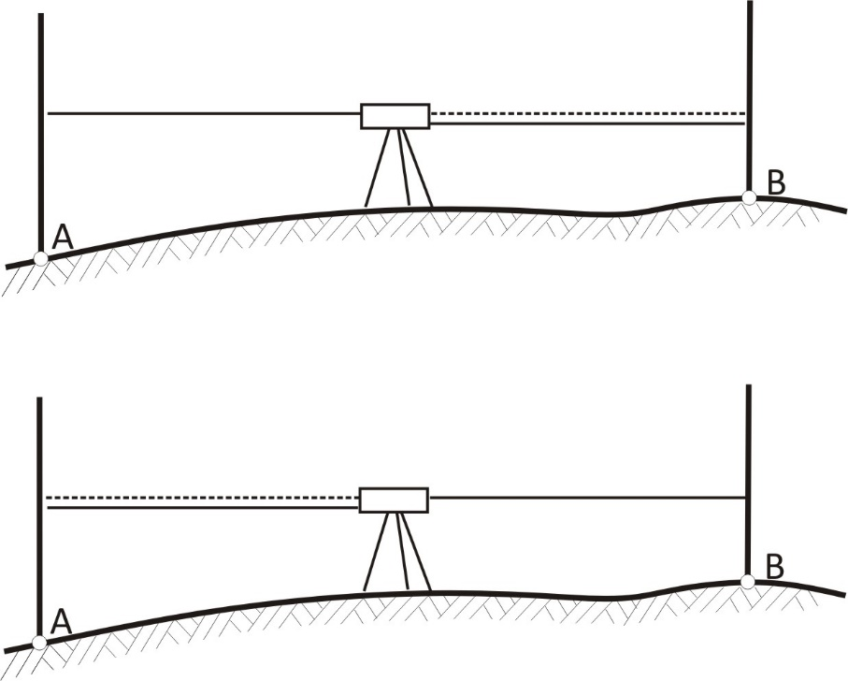

Figure 2.19 The settlement of the tripod (black line: real line of sight; backsight-foresight order: top; foresight-backsight order: bottom)

Settlement of the staff
Unfortunately not only the tripods, but the staves can settle, too. In order to minimize this effect a change plate must be used for all the change points. However the settlement of the staff increases the foresight readings only, since only that part of the vertical displacement contaminates the observed elevation difference, which occurs between observation of the backsight and the foresight readings. Thus all of the observed elevation differences tend to be smaller than the real ones.
In order to eliminate this problem, the levelling lines must be run twice in the opposite directions. Let’s suppose that the cumulative effect of the settlement of the staff is δ_{s} along a levelling line. In this case the observed elevation differenced in the forward and the backward levelling would be written as:

, and

.

The mean value of the observed elevation differences can be computed as:

,

where the negative sign takes into consideration the opposite direction of levelling.
Let’s compute the mean value of the observed elevation differences:

.

Thus the mean value of the elevation differences observed in the opposite directions is free from the effect of the settlement of the staves.

The procedure of levelling

As it could be seen in the previous sections, many systematic error sources affect the levelling observations. The methods to eliminate or minimize the effect of these sources have been discussed in details in the previous sections. In order to achieve the best results one should follow the following rules during the levelling observations.

- The surveyor’s level must be set up in the same distance from both of the staves.
- In case of a tilting level the levelling bubble must be centred before each staff reading!
- The parallax screw must not be used between the backsight and the foresight reading (it is not needed either, when the instrument-staff distances are equal).
- The bubble tube must be protected from strong heat (in case of a tilting level).
- Readings must be taken 30-50 cm above the ground to avoid the effect of refraction in the proximity of the ground.
- Staves must be set up vertically (circular bubbles must be used).
- A change plate must be used to place the staff on the change points.
- Levelling must be done in two opposite directions (two-way levelling).
- All the observations should be made with constant speed (no breaks).
- Observations must be made only in appropriate weather conditions: cloudy sky, constant temperature, early morning or late afternoon.
- Staves must be calibrated regularly.
- An even number of stations must be used to create a levelling line when two staves are used.

The application of these rules enables the mitigation of systematic error sources properly. Thus an optimal accuracy can be achieved in levelling observations.

Levelling methods and bookkeeping

In the engineering practice two different levelling methods are used. The next sections discuss these methods and introduce the processing of the levelling observations, too.

Line levelling
The principle of line levelling has already been discussed at the beginning of this chapter, therefore this section focuses on the processing issues only. Figure 2.20. shows a sectional view of a levelling line. Point A is a levelling benchmark, thus its elevation (called Reduced Level) is given: RL_{A}=103.455 m. Let’s measure and compute the reduced level of point B!
In order to solve this task a levelling line has been created between point A and B. All of the foresight and the backsight readings were taken and written in a fieldbook (see Fig. 2.21).

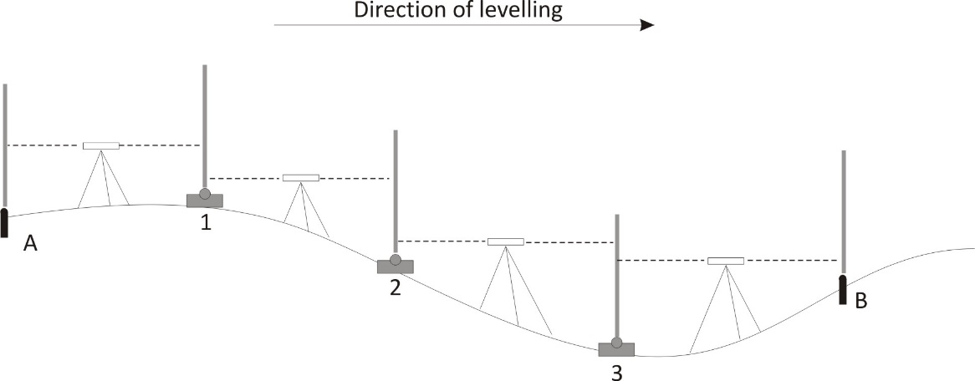
Figure 2.20 The levelling line

PID | d | BS |  | FS |  | Rise | Fall | H
A |  | 12 | 14 |  |  |  |  | 103.455
1 | 20 | 08 | 33 | 14 | 58 |  | 0.244
2 | 19 | 14 | 74 | 13 | 99 |  | 0.566
3 | 15 | 08 | 69 | 09 | 13 | 0.561
B | 13 |  |  | 11 | 25 |  | 0.256 | 102.950
 |  |  |  |  |  | 0.561 | 1.066
 |  |  |  |  |  | ΔH_{AB}=-0.505m

Figure 2.21 Bookkeeping of line levelling

Bookkeeping
The fieldbook consists of the following columns:
- Point ID
- distance between the staves (d)
- backsight readings (BS)
- foresight readings (FS)
- elevation differences (Rise/Fall)
- reduced levels (H)
The bookkeeping is done according to the following procedure:
- Firstly the first two point IDs are written in the first column. The first point is the starting benchmark (A) and the second one is the first change point.
- The distance is measured between the two staves and it is logged in the second column.
- After the instrument was set up in the same distance from both of the staves, the backsight reading is taken. Please note, that backsight reading is taken to point A, therefore the value is written in the row of point A (1214).
- Afterwards the foresight reading is taken. This reading is taken to point 1, therefore its value is written in the row of point 1 (1458).
- Afterwards the first 4 steps are carried out for all of the stations.

Processing the line levelling – one-way levelling
In this particular case a one-way levelling was done. The principle of the processing procedure is to compute the observed elevations differences at the stations. These elevation differences become ‘Rise’ values, when they are positive (levelling uphill) and they are ‘Fall’ values when they’re negative (levelling downhill). The ‘Rise’ and ‘Fall’ values are computed as the difference of the backsight and the foresight readings:

Please note that the backsight and foresight readings taken at the same station are written in consecutive rows. Therefore the first elevation difference is:

Please note that the dimension of the staff reading is mm. Since altogether four stations were established in the levelling line, four rise or fall values are computed.
The total elevation difference between the endpoints can be computed as the sum of the rise values minus the sum of the fall values. Therefore both the rise and fall values are summed up (0.561 and 1.066 respectively), and the elevation difference (ΔH_{AB}) is computed as the difference of the two values (-0.505 m).
Since the total elevation difference is known, the reduced level of the point B can be computed easily:

.

Processing the line levelling – two-way levelling
Although the reduced level of point B could have been computed in the previous section, it must be noticed that our observations could not be checked in case of one-way levelling. When a staff reading is erroneous, then the corresponding rise/fall value is wrong and the computed reduced level becomes wrong, too. In order to check our observations usually two-way levellings are carried out. Thus an additional levelling line is established between B and A. The levelling fieldbook can be found on Fig. 2.22.

PID | d | BS |  | FS |  | Rise | Fall | H
A |  | 12 | 14 |  |  |  |  | 103.455
1 | 20 | 08 | 33 | 14 | 58 |  | 0.244
2 | 19 | 14 | 74 | 13 | 99 |  | 0.566
3 | 15 | 08 | 69 | 09 | 13 | 0.561
B | 13 |  |  | 11 | 25 |  | 0.256
 |  |  |  |  |  | 0.561 | 1.066
 |  |  |  |  |  | ΔH_{AB}=-0.505m
B |  | 12 | 03
1 | 11 | 10 | 01 | 09 | 11 | 0.292
2 | 13 | 13 | 53 | 15 | 19 |  | -0.518
3 | 18 | 15 | 22 | 09 | 41 | 0.412
A | 22 |  |  | 11 | 97 | 0.325
 |  |  |  |  |  | 1.029 | -0.518
 |  |  |  |  |  | ΔH_{AB}=+0.511m

Figure 2.21 Bookkeeping of line levelling (two-way levelling)

Let’s follow the previously described procedure to compute the observed elevation difference between point B and A! The elevation difference will be:

.

Please note that theoretically the observed elevation differences should have the same absolute value when no observation error is present. However due to the committed observation error the elevation difference measured in the forward and the backward levelling has a difference of 6 millimetres. In order to adjust the results of the two observations, one should compute the mean value of the two elevation differences:

Thus the reduced level of the endpoint becomes:

Detail point levelling
In many cases of the surveying practice levelling is not used to determine the reduced level of the levelling benchmarks, but it is used to determine the reduced level of the characteristic points of existing objects. For example during the renewal of an existing sewage network it is important to know the exact elevation of the manholes. Using this information the slope of the existing pipes can be computed, which helps to estimate the capacity of the pipe system. In such cases the so called ‘detail point levelling’ is carried out.
Let’s consider the following example! The slope of an existing sewage pipe must be determined (Fig. 2.22.). In order to compute the slope, the horizontal distance between the neighbouring manholes was measured (150 metres). In order to calculate the slope, the elevation difference of the endpoints of the pipe should be measured by the levelling technique. A levelling line is established between the benchmarks A and B. During the observation of this levelling line the manholes of the sewage pipe were also measured by taking ‘intersight’ readings on the staves placed on the manhole from the nearest station.
The fieldbook of the observations are depicted on Fig. 2.23. The processing of the fieldbook follows the ‘Height-of-Collimation’ method.

The ‘Height-of-Collimation’ method
The principle of the ‘Height-of-Collimation’ method is the following. The reduced level of any object can be measured, when the reduced level of the line-of-sight (called the ‘height of collimation’) is known and a reading is taken on a staff placed on the aforementioned object. Please note that one must not place a change plate beneath the staff in this case!
The height-of-collimation in a levelling line can be computed as the sum of the reduced level of the backsight point and the backsight reading (Fig. 2.22.).
Thus the processing consists of the following steps:
- Firstly the line levelling is processed, using the backsight and foresight readings.
- When a levelling misclosure is detected (i.e. the observed elevation difference differs from the true elevation difference of the endpoints), then the misclosure error must be distributed to the observed elevation differences at the stations (to the computed rise/fall values).
- The reduced level of all of the change points are computed using the corrected rise/fall values!
- The height-of-collimation is calculated at each station (reduced level of the backsight point + the backsight reading).
- The reduced level of the detail points (i.e. the manholes) are computed as the difference of the height-of-collimation and the intersight reading!

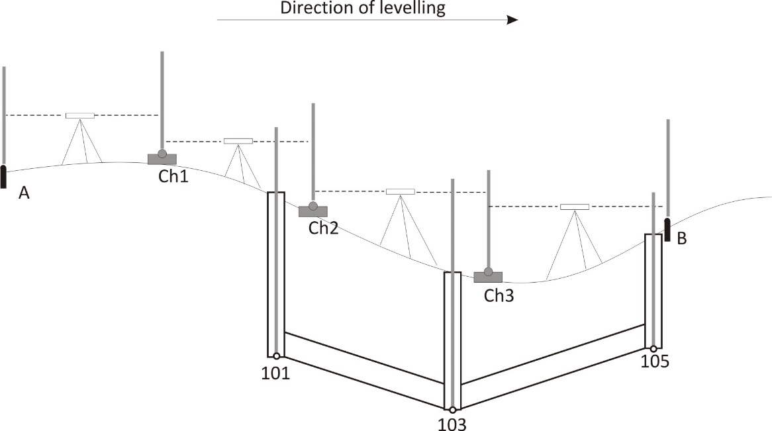

Figure 2.23 The principle of detail point levelling

Let’s see the fieldbook of the detail point levelling on Fig. 2.23. The levelling was carried out between the levelling benchmarks 1012 and 1013. The reduced levels of these benchmarks are 103.231 m AOD (above Ordnance Datum) and 104.166 m AOD respectively. Altogether three change points had to be established during the levelling (Ch.P. 1-3) and the reduced level of three detail points (101, 103 and 105) needs to be computed. Let’s see the computational steps!

- Let’s compute the elevation difference between the consecutive change points. These elevation differences can be computed as the difference of the backsight and foresight readings. The elevation differences are 269, 247, 429 and -22 mm, respectively.
- Let’s check the levelling misclosure! The true elevation difference can be computed as the difference between the reduced levels of the two benchmarks (0.935m). The sum of the observed elevation difference is equal to the observed elevation difference between the same two benchmarks (923 mm). Thus a levelling misclosure of +12 millimetres is detected. Please note that the misclosure can be calculated by the difference of the true elevation difference and the observed elevation difference:

This levelling misclosure must be corrected, therefore each elevation difference should get a correction. Generally corrections are distributed proportionally with the distance between the consecutive change points. However in this case the distances between the change points are assumed to be identical, thus the misclosure is distributed homogeneously on each elevation difference. Since altogether four elevation differences were measured, each elevation difference is corrected by +3 mm.

- Afterwards the corrected reduced level of the change points can be computed easily. Starting with the reduced level of the first benchmark, the reduced level of the points can be calculated as the sum of the reduced level of the previous point and the corrected rise/fall value.

As a final check one must obtain the true reduced level of the final benchmark (1013) by adding the reduced level of the last change point and the last corrected rise/fall value:

- The height of collimation can be calculated as the sum of the reduced level of the benchmarks/change points and the backsight reading taken to the same point.
- Finally the reduced level of the detail points are calculated as the difference of the height of collimation and the intersight readings taken to the detail point.

For detail point No. 101:

For detail point No. 103:

For detail point No. 105:

P.ID. | Backsight | Intersight | Foresight | Rise/Fall | Height of collimation | Reduced Level
1012 | 1234 |  |  |  | 104.465 | 103.231
Ch.P1 | 1012 |  | 0965 | 0269 + (3) | 104.515 | 103.503
101 |  | 0986 |  |  |  | 103.529
Ch.P2 | 1452 |  | 0765 | 0247 + (3) | 105.205 | 103.753
103 |  | 2312 |  |  |  | 102.893
Ch.P3 | 1001 |  | 1023 | 0429 + (3) | 105.186 | 104.185
105 |  | 1532 |  |  |  | 103.654
1013 |  |  | 1023 | -0022 + (3) |  | 104.166 (ok)
 |  |  |  | Σ 0923 mm |  | 0.935m
 |  |  |  | Δ = +12 mm

Figure 2.23 Bookkeeping of detail point levelling

Angular observations

We have introduced the basic principles of height determination in the previous chapter. Since the aim of surveying is to determine the position of points in the three-dimensional world, therefore we’re going to focus on the observations needed for the horizontal positioning.
It was already mentioned that horizontal positions can be computed by measuring horizontal angles or horizontal distances or both from existing benchmarks. This chapter focuses on the observation of horizontal (and vertical) angles.
First of all the term horizontal and vertical angles must be defined. Let’s imagine that we have three points on the topography (A,B and C). In order to compute coordinates, the horizontal angle between the BA and BC directions should be measured. Horizontal angles are defined as the angle between two vertical planes formed by the local vertical (the gradient vector of Earth’s gravity field) at point B (the station) and the targets A and C, respectively.
Vertical angles are defined as the angle between the local vertical at the station (B) and the line-of-sight pointing to the target (A or C).
In order to measure these angles, a special instrument is needed, which:
- contain two fixed graduated circles, which can be set in a horizontal and in a vertical position;
- has an upper part with a telescope, which can be revolved around a ‘vertical’ axis;
- has a rotatable telescope mounted on a ‘horizontal’ axis;
- contains some bubble tubes to help in the perfect orientation of the ‘horizontal’ and ‘vertical’ axis.

The structure of the theodolite

This instrument is called: the theodolite. The structure of the instruments is depicted on Fig. 3-1.
The theodolite consists of a tribrach, which can be mounted on a tripod for field observations. The tribrach contains the levelling screws.
One of the most important part of the instrument is the standing axis. The standing axis must coincide with the local vertical for proper observations. In order to ensure that the extension of the standing axis crosses the benchmark an optical plummet is mounted either on the tribrach or on the alidade. This optical device contains a small prism, with which the position of the extension line of the standing axis can be monitored.
The horizontal circle is mounted on the standing axis, while the upper part of the instrument, the alidade can be revolved around the standing axis. The angular position of the alidade can be read on the horizontal circle by the horizontal reading eyepieces.

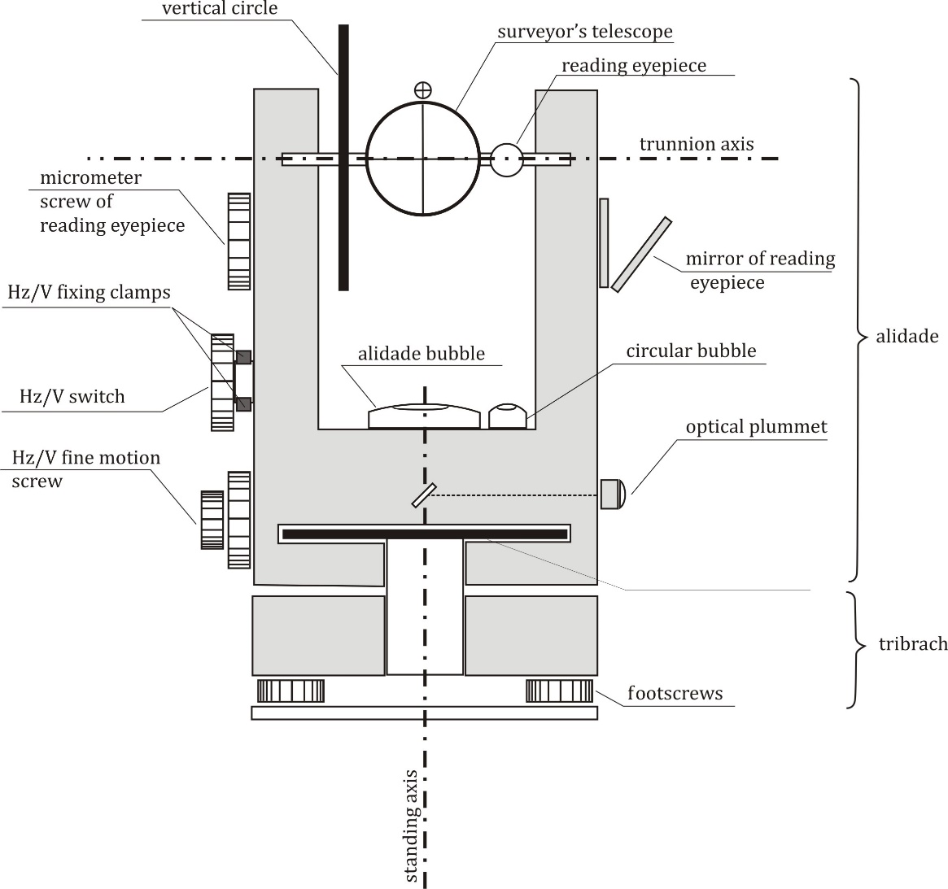

Figure 3-1. The structure of the theodolite

Since the standing axis of the instrument must be in a vertical position during the observations, the instrument contains some plate bubbles to ensure this position. A circular bubble is used to set the standing axis approximately, while the alidade bubble is used for ensuring the properly vertical position of the standing axis.
The alidade contains the trunnion axis, which is perpendicular to the standing axis. The telescope is mounted on the trunnion axis and can be rotated around it. The tilting angle of the telescope with respect to the local vertical is measured on the vertical circle. The vertical circle is mounted on the alidade so, that its index coincides with the local vertical.
In order to ensure the precise readings both the alidade and the telescope can be fixed for the observation using the horizontal and vertical fixing clamps. The precise sighting of the targets can be achieved by using the horizontal and vertical fine motion screws.
It must be noted that precise readings (with the precision of a few arc-seconds or even better) could not be taken without proper reading eyepieces, which zoom the graduation of the circles and provide some additional tools to enhance the accuracy of the reading.

Reading eyepieces
The role of the reading eyepieces is to enhance the precision of the circle readings. Thus they are necessary for accurate horizontal and vertical angular observations. Since the diameters of the horizontal and vertical circles are limited due to the size and mass restrictions of the instrument, therefore the graduations are usually made with the resolution of 20’ to 1°. Since the accuracy of a few arc-seconds must be achieved in the angular observations, therefore the graduation lines must be enlarged with some optical elements and some additional tools are needed to enhance the precision of the circle readings. In the following sections the operation of the graduated microscopes and the coincidence readers are discussed.

Graduated microscopes
The principle of the operation of graduated microscopes is quite straightforward. Let’s assume that both the horizontal and vertical circles have a graduation with the resolution of 1°. In order to enhance the accuracies, a microscope enlarges the view of the consecutive degree graduations, which are closest to the position of the line-of-sight. Moreover an additional scale is projected to the view. The length of this scale is identical to the distance between the two degree graduation lines and it consists of 60 units. Thus 1 unit corresponds to 1 arc-minute. The view of such a graduated microscope can be seen on Fig. 3-2.

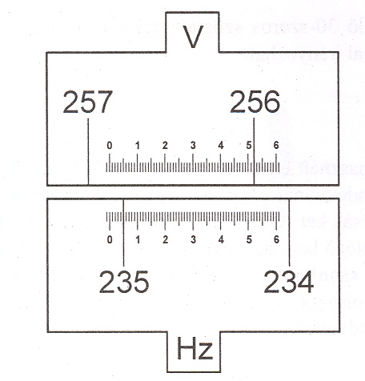

Figure 3-2. The view of the graduated microscope

The position of the line-of-sight (the direction of the telescope) coincides with the 0 index of the projected scale. Although the degree graduations increase clockwise on the circles, optically they are mirrored in the reading eyepieces. Thus the degree graduations increase from the left to the right in the reading eyepiece of the graduated microscope.
Let’s take a reading on the horizontal circle using the graduated microscope on Fig. 3-2! Since the scale intersects the degree graduation of 235° (the index of the scale is located on the left side of this graduation), therefore the reading is bigger than 235°. The proper reading is taken by determining the position of this degree graduation on the scale. By zooming this intersection a little bit, the position can be read by estimating the fractional reading, too. Since the position of the degree graduation is 4.8 units, therefore the total reading is: 235° 04.8’. Converting this value to the degree-minute-second (DMS) format one gets: 235° 04’ 48”.
Thus angles can be measured with the precision of approximately 6 arc-seconds using this technique.

Coincidence reader
Another way to enhance the accuracy of the circle readings is the application of the coincidence readers. In this case two virtual indices are used in diametral positions for the readings (Fig 3-3.). The diameter defined by the location of the indices coincide with the line-of-sight of the instrument.

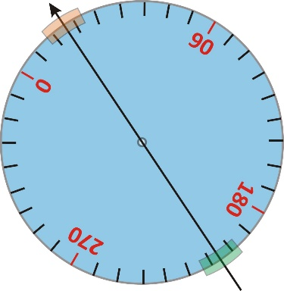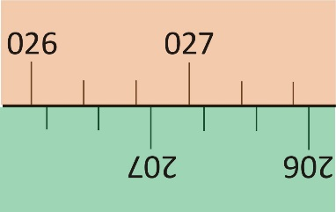

Figure 3-3. The principle of the coincidence reader (left: indices of the coincidence reader; right: the view of the two indices in the reading eyepiece)

These indices are projected to the same view in the reading eyepiece. One should note that the projected scales are incremented in different direction. The upper one increases from the left to the right (since this is scale is note mirrored and the circles are incremented clockwise), while the lower one increases from the right to the left. Since the difference of the readings is exactly 180° for a diametral index pair, therefore one should find the middle of the scales in order to obtain the true horizontal reading. Thus the reading of Fig. 3-3. would sound approximately 26°55’ .
It is easy to see that the aforementioned technique is not accurate enough, therefore the rays of lights projecting the diametral indices of the horizontal circle are driven through plane parallel plates. It is well known that plane parallel plates offset the rays parallel to their original positions, when the angle of incidence differs from 90°. When the plane parallel plate is rotated in a position that both of the upper and lower scales coincide in the view of the reading eyepiece (Fig. 3-4.), then the reading of the indices can be taken easily. The reading according to Fig. 3-4 is 26° 50’. However it must not be forgotten that the scales were offset by the rotation of the plane parallel plates. Fortunately this rotation angle is converted to horizontal readings and they are displayed in the reading eyepiece directly. Thus the total angular reading is: 26°57’57.5”.

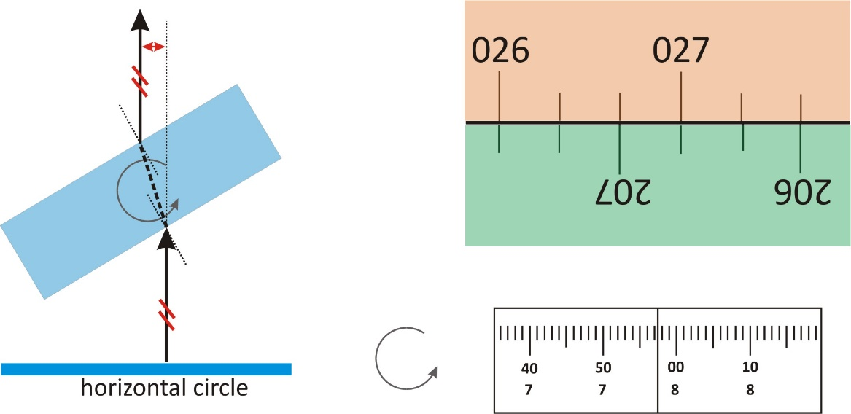

Figure 3-4. The operation of coincidence reader (left: plan parallel glass plates are used to shift the view of the graduated circles; right: view of the reading eyepiece after the coincidence is achieved)

The Theo 010B instrument contains an advanced version of coincidence reader. On this instrument the graduation lines are represented by the twin lines on the lower left part of the reading eyepiece. By the rotation of the micrometer screw these twin lines can be aligned, and the degree, decimal minute and minute/seconds values can be read directly.

The alidade bubble
In order to be able to measure horizontal and/or vertical angles, the instrument must be levelled properly. The theodolite is usually equipped with an alidade bubble, which is mounted on the alidade. Due to manufactural and instrumental inaccuracies, the axis of this alidade bubble is usually in an oblique position with respect to plane of the horizontal circle (in other words: the axis of the alidade bubble is not perpendicular to the standing axis). Thus when the alidade bubble is centered, the horizontal circle and the standing axis are tilted.
Since the standing axis must be vertical throughout the observations, therefore the alidade bubble must be set to the – so called – normal point. The normal point is the position of the alidade bubble, which is shown when the standing axis is vertical (thus the tangent line drawn to the normal point is exactly perpendicular to the standing axis).
Fig. 3-5 shows the characteristic points of the alidade bubble. ‘C’ denotes the center of the bubble, while ‘O’ denotes the center of the scale on the alidade bubble. Finally ‘N’ is the normal point of the bubble tube. It can be seen that the tangent line drown to N is exactly perpendiculat to the standing axis. The location of the normal point depends on the angle between the alidade (horizontal circle) and the axis of the alidade bubble. When this angle is zero (N=O) then the alidade is adjusted to the standing axis. When the center of the bubble coincides with the normal point (C=N) then the standing axis becomes vertical.

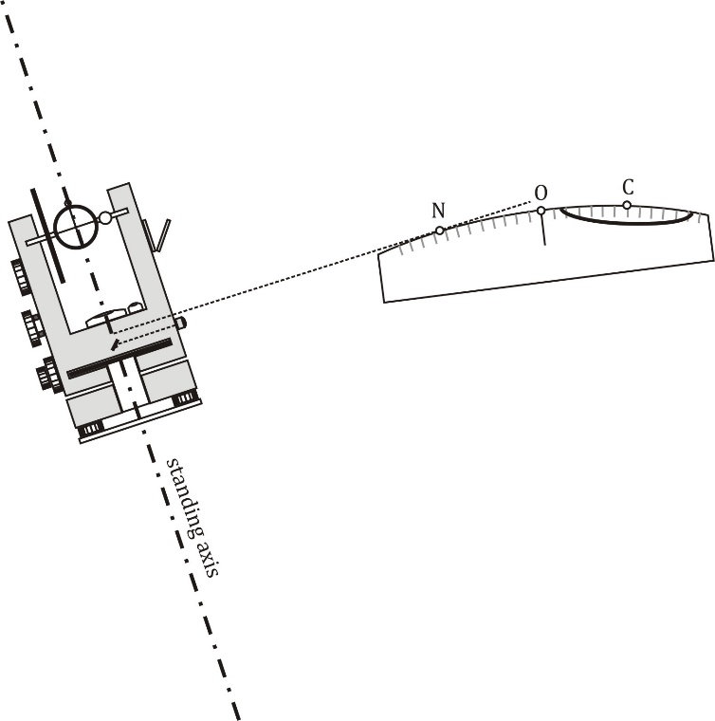

Figure 3-5. Characteristic points of the alidade bubble (N: normal point; O: scale center; C: center of bubble)

References

Vanicek, P., Krakiwsky, E.J. (1986) Geodesy: The Concepts. Elsevier Science, p 697.

